## Capital flow estimation (search for Jim O'Neil + weekly analyst):

1. Valuation: high valuation area are incentivised to do M&A in low valuation area

2. Using effective M&A to estimate the FDI

3. bond flow: use bond yield spread to estimate

4. trade weighted dollar, relative import prices -> export and import

5. world financial conditions -> world growth perspective

6. oil prices

7. TIC flow (flow logic: can't sketch forever?) Foreign purchase of US equity

8. import: value, volume, oil prices

9. FX reserve build up: vulnerability

10. electronic price: DRAM price?

11. Asian terms of trade: oil and DRAM prices

12. MOF flows for Japan

13. Bond benchmark adjustment

14. portfolio managers of bond allocation

15. interest rate differential

16. portfolio flow estimate: a- valuation (dividend yield, pension fund inflow??, multiples). b- positioning: sentix, TIC, zew, AAII?, economic consensus

17. import/export category: capital goods (investment spending), industrial supplies, autos, consumer goods(consumer spending).; energy, non-energy (commodities prices);

Mudit 2019-12-20

Adding couple more broker reviews for month end – average seems to be 30-35 Bn US equities to sell depending how much weighting they assign to quarterly rebalance, still worth 1-1.5% in spot.

**From MS :**

The Morgan Stanley QDS Pension Rebalancing Model estimates that there will be $11bn of outflows from US Equities over December month-end, with ~half of that flow expected to go into non-US Equities and half into Fixed Income and other assets.  $11bn outflows from US Equities is the 37th percentile since 2005.  The outflows from US Equities and inflows to non-US Equities result in net $6bn outflows from Equities overall, which is in-line with the median for aggregate Equities since 2005.  Note that these estimates may be smaller than other models because QDS models monthly rebalances, not quarterly, as price action exhibits more mean reversion around month-ends compared to quarter-ends.  Additionally, while the expected flow is not tremendous in size, subsequent price action could be exacerbated by low liquidity near year-end.

**From GS :**

**As of the close on Thursday, December 19th, the desk’s theoretical, model-based assumption estimates a net $40 billion of equities to sell from calendar-based flow given the moves in equities and bonds over the quarter:**

•         For the fourth quarter of 2019, equities **outperformed**fixed-income by 9.49% (S&P total-return +8.17%, 10yr total-return -1.32%). As a result, we estimate quarterly rebalancing flow of **$30 billion of equities to sell\***

•         Also, for the month of December, the S&P 500 has **outperformed**U.S. T-notes by 2.99% (SPX total-return +2.16%, 10-yr total-return -0.83%). This results in monthly estimated rebalancing flow of **$10 billion of equities to sell\***

•         Lastly, we saw one “trigger” event in the month of December, occurring on 12Dec19**.**

o   Equities cumulatively outperformed fixed-income by a 6.17% spread up to that date, leading to a net **$9 billion of equities to sell**

**Note: our assumption is trigger rebalancing occurs at/around time of event.**

Rebecca highlighting internals still good. Worth noting that she expects 50 Bn USD of equity selling into year end, this seems on the high side but could be worth 1.5-2% in spot as per historical impacts. Below is SPX price chart for end 2017 where we couldn’t rally despite tax cuts passing and ended the year at 2 week lows because of roughly 25 Bn equities selling (was a buying opportunity).

**From:** rebecca.cheong@ubs.com [mailto:rebecca.cheong@ubs.com]   
**Sent:** 20 December 2019 00:25  
**To:** Mehta, Mudit  
**Subject:** [EXTERNAL] We are only half-way there – more upside in 2020Q1

We are only half-way there – more upside in 2020Q1

### Sales and Trading commentary, not a product of UBS Research. For Institutional Investors only ###

**Upcoming Teach-in Events:**

•         Wednesday, 15 January 2020 in **Singapore**

•         Thursday, 16 January 2020 in **Hong Kong** – We are at ~90% capacity, please contact your local sales for invitation if you are interested

•         Wednesday, 29 January 2020 in **Sao Paolo**

•         Wednesday, 5 March 2020 in**Sydney**

**Summary:**

**I will be on block leave for the next two weeks and back on January 6.  Last year, I saw the Northern Lights in Iceland.  This year, we are heading to Niseko in Hokkaido, Japan to enjoy some dry snow skiing.  Stay warm!  Merry Christmas & Happy New Year!!!!!**

•         I have been getting a lot of questions if the recent rally has changed my view – answer is no.  Q4 return so far has been in-line with my expectation of +5-10%.  So far, SPX is up 8% QTD

•         I remain bullish into 2020Q1 since upside dislocation just started in Sep 2019 in our model and it should last more than 3 months

•         Investor positioning has gone from extremely bearish to moderate with many positioning hovering around 40%-70%-tile ranks – no stretched position yet

•         Our CTA model shows that we are just at the beginning of a strong momentum period (not the end) and we are far away from meaningful sell triggers currently

•         Based on intraday recovery score comparison since 2011, current year-end trend is the strongest with 2M score @ 32%, a rise of +13% vs 1M ago.  Normally, a stable recovery score (sentiment) at prior year-end was good enough to support a beginning of year grind higher trends in 2012 (+12% in Q1), 2013 (+12% in Q1) and 2017 (+8% in Q1).  During those periods, beginning of year buying demand wasn't met by investors dumping stocks since recovery score (conviction) didn’t collapse

•         Lastly, I expect the typical Q4 hedge fund upside chasing to be delayed into Q1 as many funds have cut down their risks (both net and gross) early on to lock in their performance gain this year, post a challenging 2018 year

•         One major sell risk before year-end is pension year-end rebalancing of up to $50 bil of equity to sell – the largest month-end selling since Dec 2016.  Since our other market internal models remain healthy, use this opportunity to buy the dip to gain upside exposure into Q1 2020

**Overview:**

**I have been getting a lot of questions if the recent rally has changed my view – answer is no**.  Q4 return so far has been in-line with my expectation of +5-10% (vs 8% QTD) and below is why I remain bullish into 2020Q1.

•         **Figure 1:** Our model focuses on **major dislocation signs** especially when conviction and leverage deviates significantly as depicted in Figure 1.  Our model shows major downside risk where conviction dropped too fast vs a rising leverage in early Oct 2018, as well as major upside risk where **conviction rose sharply vs an extremely low leverage in early Sep 2019**.  We are just 3 months into this low volatility, grind higher rally and there should be **more room to go in 2020** given the significance and rarity of the dislocation

•         **Figure 7:** In Sep, our model output was obvious as conviction was very strong from intraday recovery score to excess flow while leverage was very low from UBS PB, CFTC, hedged positioning to retail flows.  In Oct and Nov, while conviction has remained strong and stable, **investors were fighting the rally which lengthened and extended the rally, and reinforced our high conviction in Q4 upside**

•         **Figures 11, 15-19:** Finally, over the last two weeks in Dec, we started to see **positioning get longer but nothing are over-stretched yet** with many positions hovering around 40-70%-tile versus 3Y history – CFTC lev fund exposure in SPX futures @ 14%-tile, VIX ETN + CFTC VIX futures @ 80%-tile (i.e. well-hedged), SPY P/C ratio @ 47%-tile, UBS PB Net exposure @ 51%-tile, Risk Control leverage @ 58%-tile and Risk Parity leverage @ 75%-tile.  Even for CTA exposure, although they are around 80%-100% long global equities, the **long-term strategies just turned long less than 3 months ago**.   This marked the **beginning of a strong momentum period (not the end) and we are far away from meaningful sell triggers currently**

•         **Figures 2 – 6:** In particular, as we compare the current intraday recovery score trend vs past year-ends, **the current condition is one of the strongest at a high level and a rising trend**.  As shown in figures 2 – 5, when recovery score collapsed into year-end, it tended to lead a sell-off immediately after new year (2014, 2015, 2016, 2018 – Figures 4 & 5).  However, **as long as recovery score (sentiment) remained stable at prior year-end**, the typical beginning of year buying demand from retail investors, retirement funds and hedge fund managers were enough to create a **continuously grind higher market in Q1 (2012, 2013, 2017 – Figures 2 & 3).**  So far in Dec, recovery score is not only strong, it has been rising, which suggests that there is a low likelihood of investors changing their trading behavior and conviction drastically and dumping stocks at the beginning of 2020

•         Lastly, one of the typical key drivers of Q4 seasonality is usually hedge fund upside chasing in a strong equity return year.  However, the loss in 2018, followed by a strong performance in 2019 have caused many funds to cut risk significantly (both net and gross) into year-end to lock in their performance gain.  I believe this has **inevitably delayed the normal Q4 upside chasing into Q1 with a bias in bargain hunting to set up for 2020**

•         One major sell risk before year-end is pension year-end rebalancing of up to $50 bil of equity to sell – the largest month-end selling since Dec 2016.  Since our other market internal models remain healthy, use this opportunity to buy the dip to gain upside exposure into Q1 2020

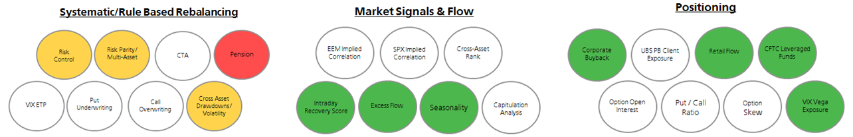

**Figure 1**

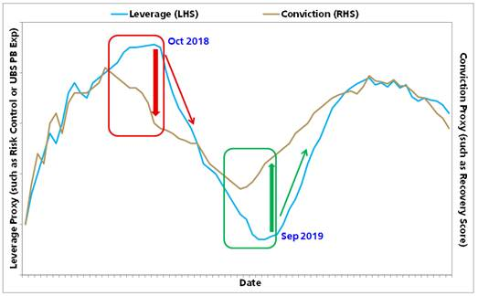

**Figures 2 - 5**

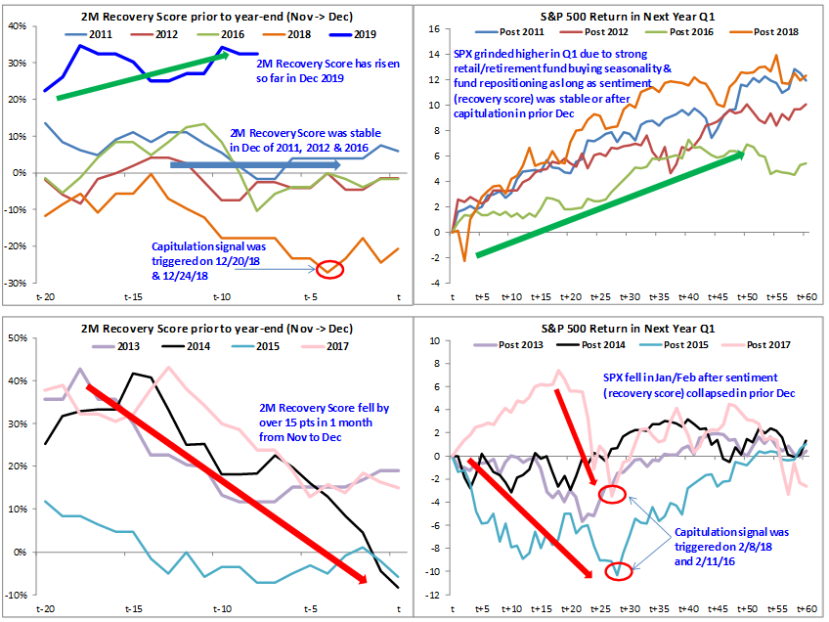

**Figure 6**

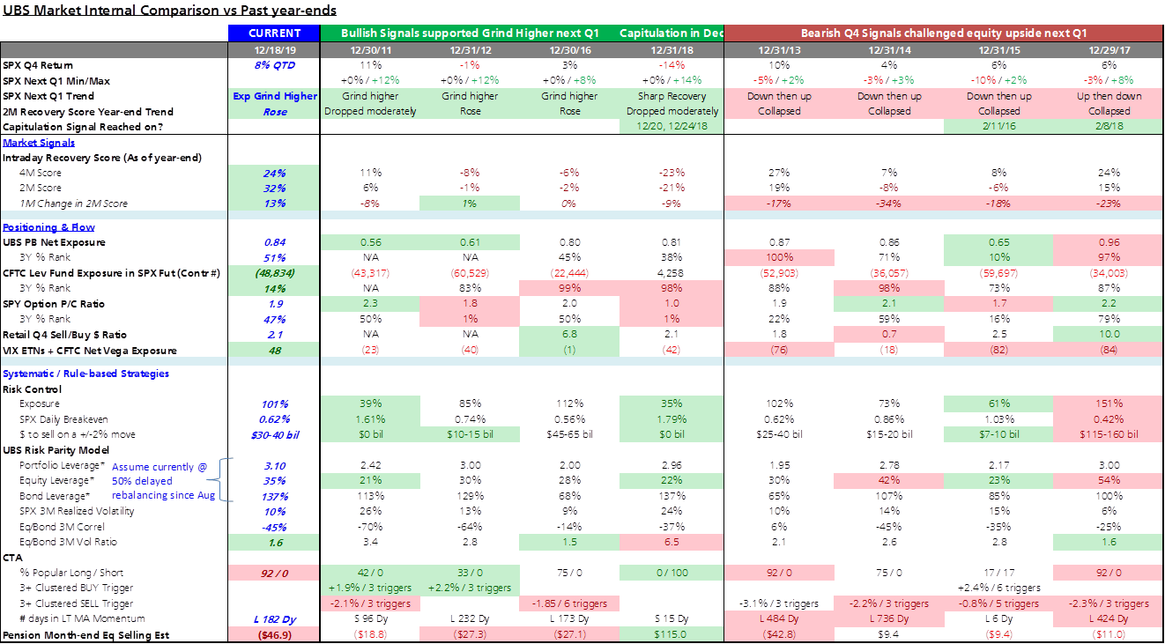

**Key Reports in late 2018 & 2019:**

Oct 10, 2018 – [A perfect storm is brewing](https://nam03.safelinks.protection.outlook.com/?url=https%3A%2F%2Fneo.ubs.com%2Fr%2F%3Fid%3Dhb6ac92%2C1a17062%2C1a1714a%26inst%3DV7%0D%0A%26did%3DAC7-S-27357282%26off_id%3DAC7-S-13687377395613%26ma%3DY4E494B414E4A4543%26camp_id%3DEM%3AUNKW%3A2019-12%3A19%3ASmartEmail&data=02%7C01%7Cmmehta%40caxton.com%7C627432386eca4bccdafc08d784e3a56b%7C70c99524736c49f4b73e75d7fa126cf9%7C0%7C0%7C637123985589725203&sdata=WHVXvYZwm2WcJEWOaTJ18XRH%2Fb4CjEWqzTRnC00BE%2BI%3D&reserved=0)

Dec 11, 2018 – [A coincidence or NOT? – 1998, 2000, 2008, 2018](https://nam03.safelinks.protection.outlook.com/?url=https%3A%2F%2Fneo.ubs.com%2Fr%2F%3Fid%3Dhb6ac92%2C1a17062%2C1a1714b%26inst%3DV7%0D%0A%26did%3DAC7-S-27357282%26off_id%3DAC7-S-13687377395614%26ma%3DY4E494B414E4A4543%26camp_id%3DEM%3AUNKW%3A2019-12%3A19%3ASmartEmail&data=02%7C01%7Cmmehta%40caxton.com%7C627432386eca4bccdafc08d784e3a56b%7C70c99524736c49f4b73e75d7fa126cf9%7C0%7C0%7C637123985589725203&sdata=dahD7PLxSA7pmMIm8lbDwH9nOhQQ%2FtrWR1wtNn%2F94tU%3D&reserved=0)

Jan 14 – [Excess](https://nam03.safelinks.protection.outlook.com/?url=https%3A%2F%2Fneo.ubs.com%2Fr%2F%3Fid%3Dhb6ac92%2C1a17062%2C1a1714c%26inst%3DV7%0D%0A%26did%3DAC7-S-27357282%26off_id%3DAC7-S-13687377395615%26ma%3DY4E494B414E4A4543%26camp_id%3DEM%3AUNKW%3A2019-12%3A19%3ASmartEmail&data=02%7C01%7Cmmehta%40caxton.com%7C627432386eca4bccdafc08d784e3a56b%7C70c99524736c49f4b73e75d7fa126cf9%7C0%7C0%7C637123985589735199&sdata=6FV1mIoyjnxoJE2dF3Ismhnozqz9UsdJPYGAkzzCUxY%3D&reserved=0)[flow supports our bearish view – 2600 resistance, 2200 downside](https://nam03.safelinks.protection.outlook.com/?url=https%3A%2F%2Fneo.ubs.com%2Fr%2F%3Fid%3Dhb6ac92%2C1a17062%2C1a1714d%26inst%3DV7%0D%0A%26did%3DAC7-S-27357282%26off_id%3DAC7-S-13687377395616%26ma%3DY4E494B414E4A4543%26camp_id%3DEM%3AUNKW%3A2019-12%3A19%3ASmartEmail&data=02%7C01%7Cmmehta%40caxton.com%7C627432386eca4bccdafc08d784e3a56b%7C70c99524736c49f4b73e75d7fa126cf9%7C0%7C0%7C637123985589735199&sdata=4r3SyEMRrNnBPdDxKYJxNEXEJTZy9%2BNWCl%2F%2FM6ZonDc%3D&reserved=0)

Feb 4 – [External Catalyst resets Market Internals](https://nam03.safelinks.protection.outlook.com/?url=https%3A%2F%2Fneo.ubs.com%2Fr%2F%3Fid%3Dhb6ac92%2C1a17062%2C1a1714e%26inst%3DV7%0D%0A%26did%3DAC7-S-27357282%26off_id%3DAC7-S-13687377395617%26ma%3DY4E494B414E4A4543%26camp_id%3DEM%3AUNKW%3A2019-12%3A19%3ASmartEmail&data=02%7C01%7Cmmehta%40caxton.com%7C627432386eca4bccdafc08d784e3a56b%7C70c99524736c49f4b73e75d7fa126cf9%7C0%7C0%7C637123985589745197&sdata=YaieN5ToDyiov6WNdWVwvFrKshiI%2FUUbPFh95efNRnY%3D&reserved=0)

May 21 – [Market conditions are set up well for another surprise equity rally](https://nam03.safelinks.protection.outlook.com/?url=https%3A%2F%2Fneo.ubs.com%2Fr%2F%3Fid%3Dhb6ac92%2C1a17062%2C1a1716d%26inst%3DV7%0D%0A%26did%3DAC7-S-27357282%26off_id%3DAC7-S-13687377395648%26ma%3DY4E494B414E4A4543%26camp_id%3DEM%3AUNKW%3A2019-12%3A19%3ASmartEmail&data=02%7C01%7Cmmehta%40caxton.com%7C627432386eca4bccdafc08d784e3a56b%7C70c99524736c49f4b73e75d7fa126cf9%7C0%7C0%7C637123985589745197&sdata=kWq13gfHP1hZnNbiSFChSUEatzD1JErNzGEBIoUAcXU%3D&reserved=0)

Aug 26 – [Current market internal is the strongest since May](https://nam03.safelinks.protection.outlook.com/?url=https%3A%2F%2Fneo.ubs.com%2Fr%2F%3Fid%3Dhb6ac92%2C1a17062%2C1a1716e%26inst%3DV7%0D%0A%26did%3DAC7-S-27357282%26off_id%3DAC7-S-13687377395649%26ma%3DY4E494B414E4A4543%26camp_id%3DEM%3AUNKW%3A2019-12%3A19%3ASmartEmail&data=02%7C01%7Cmmehta%40caxton.com%7C627432386eca4bccdafc08d784e3a56b%7C70c99524736c49f4b73e75d7fa126cf9%7C0%7C0%7C637123985589755194&sdata=lTaWz72HXO7%2Fmcn4OOhjdJVtUT%2FdnJpz68AWTj1vGtM%3D&reserved=0)

Sep 5 – [The most green bubbles in two years – Turning more bullish](https://nam03.safelinks.protection.outlook.com/?url=https%3A%2F%2Fneo.ubs.com%2Fr%2F%3Fid%3Dhb6ac92%2C1a17062%2C1a1716f%26inst%3DV7%0D%0A%26did%3DAC7-S-27357282%26off_id%3DAC7-S-13687377395650%26ma%3DY4E494B414E4A4543%26camp_id%3DEM%3AUNKW%3A2019-12%3A19%3ASmartEmail&data=02%7C01%7Cmmehta%40caxton.com%7C627432386eca4bccdafc08d784e3a56b%7C70c99524736c49f4b73e75d7fa126cf9%7C0%7C0%7C637123985589755194&sdata=9uqZlhUBpD4udU2d7P1NR9XdLw1kQ7%2Fn7%2Bgsb18k7yk%3D&reserved=0)

Sep 24 – [Upside Dislocation Drivers + Q4 Seasonality Support](https://nam03.safelinks.protection.outlook.com/?url=https%3A%2F%2Fneo.ubs.com%2Fr%2F%3Fid%3Dhb6ac92%2C1a17062%2C1a17170%26inst%3DV7%0D%0A%26did%3DAC7-S-27357282%26off_id%3DAC7-S-13687377395651%26ma%3DY4E494B414E4A4543%26camp_id%3DEM%3AUNKW%3A2019-12%3A19%3ASmartEmail&data=02%7C01%7Cmmehta%40caxton.com%7C627432386eca4bccdafc08d784e3a56b%7C70c99524736c49f4b73e75d7fa126cf9%7C0%7C0%7C637123985589755194&sdata=mO2sgj6nmfyL%2BXFqgcekCd4VLZ9kBtlzb55q%2FKkxJ%2Fc%3D&reserved=0)

Oct 28 – [Conviction in Q4 +5%-10% rally remains high](https://nam03.safelinks.protection.outlook.com/?url=https%3A%2F%2Fneo.ubs.com%2Fr%2F%3Fid%3Dhb6ac92%2C1a17062%2C1a17171%26inst%3DV7%0D%0A%26did%3DAC7-S-27357282%26off_id%3DAC7-S-13687377395652%26ma%3DY4E494B414E4A4543%26camp_id%3DEM%3AUNKW%3A2019-12%3A19%3ASmartEmail&data=02%7C01%7Cmmehta%40caxton.com%7C627432386eca4bccdafc08d784e3a56b%7C70c99524736c49f4b73e75d7fa126cf9%7C0%7C0%7C637123985589765182&sdata=3k22gyZ%2FxfFs5WmPkwzjrZmZ7HH3y7B66QVwYgHyHsA%3D&reserved=0)

Dec 5 – [Strong market signals + Well-hedged positions - grind higher into early 2020](https://nam03.safelinks.protection.outlook.com/?url=https%3A%2F%2Fneo.ubs.com%2Fr%2F%3Fid%3Dhb6ac92%2C1a17062%2C1a17172%26inst%3DV7%0D%0A%26did%3DAC7-S-27357282%26off_id%3DAC7-S-13687377395653%26ma%3DY4E494B414E4A4543%26camp_id%3DEM%3AUNKW%3A2019-12%3A19%3ASmartEmail&data=02%7C01%7Cmmehta%40caxton.com%7C627432386eca4bccdafc08d784e3a56b%7C70c99524736c49f4b73e75d7fa126cf9%7C0%7C0%7C637123985589765182&sdata=r%2Bj1ZRUqaszTpXLcSttajp9t4rZ5zG1pWLBfq11Qw6k%3D&reserved=0)

**Model Details:**

**Market Signals**

•         ***Intraday Recovery Score (Figure 7):*** 2M Recovery Score has risen to 32% while 4M Score remains at 24% => still bullish

•         ***Excess Flow:*** In a grind higher market, excess flow is expected to be low to nothing since investors only need to adjust their portfolios marginally.  During this time, we focus more on the relative volume across products instead of above average flow.  Since mid-Oct, cash volume has led the market 75% of the time where cash volume/average exceeded both SPY and SPX futures volume/average by at least 15%.  This suggests a healthy longer term investment environment instead of speculative short-term trading, and is supportive of a grind higher market

•         ***Seasonality (Figure 8):*** In "[9/24 Upside Dislocation Drivers + Q4 Seasonality Support](https://nam03.safelinks.protection.outlook.com/?url=https%3A%2F%2Fneo.ubs.com%2Fr%2F%3Fid%3Dhb6ac92%2C1a17062%2C1a17173%26inst%3DV7%0D%0A%26did%3DAC7-S-27357282%26off_id%3DAC7-S-13687377395654%26ma%3DY4E494B414E4A4543%26camp_id%3DEM%3AUNKW%3A2019-12%3A19%3ASmartEmail&data=02%7C01%7Cmmehta%40caxton.com%7C627432386eca4bccdafc08d784e3a56b%7C70c99524736c49f4b73e75d7fa126cf9%7C0%7C0%7C637123985589775180&sdata=clLO2H8U1ZItYgS5wv%2B8eMuGzTTLQklMoylXdtGV1XM%3D&reserved=0)," we highlighted the case for a strong Q4 seasonality this year.  So far, we are up 8% QTD.  Based on historical analysis of intraday recovery score vs seasonality buying from retail investors and fund managers in Q1, we expect the grind higher trend to continue into 2020.  In particular, the net buying impact from investors was strong in Q1 historically when their sentiment (as measured by recovery score) was stable at year-end.  Lastly, the hedge fund upside chasing phenomenon that we expected in Q4 only partially played out as some strong performing funds chose to wind down their book/risk before year-end to lock in gain instead of chasing upside.  For these funds, I expect them to deploy capital again in 2020 and simply delayed their buying demand from Q42019 to Q12020

**Systematic/Rule-based Rebalancing**

•         ***Risk Control Funds (Figure 9):*** Current SPX 10% RC fund leverage @ ~100% or 58%-tile vs 3Y history.  We continue to expect them to add ~10% (at least $30-40 bil) in the coming month with daily breakeven @ 62 bps.  Historically, 130%-150% was the leverage level that could trigger large systematic selling so we are still far away from it.  If we shock SPX -2% for one day in Feb 2018, Oct 2018 and the current, our model estimated $95-135 bil, $65-95 bil and $30-40 bil of equity selling respectively.  Therefore, although risk control rebalancing risk has risen, it remains under control and is not likely to last for more than two days.

•         ***Risk Parity Funds (Figure 10):*** UBS Risk Parity model expected significant asset allocation from bond to equity over the last few months.   However, the moderate weakness in treasury bonds suggested that rebalancing was likely very slow.  Hence, we assume that only 50% of the rebalancing was executed, and their current equity exposure is estimated ~75%-tile and bond exposure ~52%-tile vs 3Y history. With a close to 10Y low equity/bond 3M realized volatility ratio @ 1.7x, equities should continue to benefit from asset allocation by multi-asset & risk parity rebalancing

•         ***CTA Funds (Figure 11):*** CTA funds started to be long equities globally but since it is just the beginning, there is almost no sell triggers and buy triggers.  In fact, most strategies have been in the long-term strategy for less than 80 days, which imply an early stage of an upside momentum trend which could last for many more months before it turns

•         ***Put Underwriting & Call Overwriting Funds:*** S&P 500 is up ~3-4% vs expiration week in Nov.  We expect many put underwriters and call overwriters have already rolled up their options prior to expiry tomorrow, so short-term buying boost for them should be small

•         ***Pension Funds (Figures 12 & 13):*** Our model estimates pension month-end selling @ 50 bil with $33 bil from month-end rebalancing and $17 bil from monthly triggered rebalancers.  This is one of the biggest monthly sell rebalancing since Dec 2016, so we expect their selling could exert some pressure to the market during the upcoming holiday season when liquidity is low.   Since our other market internal models remain healthy, use this opportunity to buy the dip to gain upside exposure into Q1 2020

**Positioning & Flow**

•         ***UBS PB Exposures (Figures 14 & 15):*** UBS gross exposure has risen to 2.29x while net has fallen to 0.84x, at 29%-tile and 51%-tile vs 3Y history respectively.

•         ***UBS RMM Flow:*** Since end of Jan 2019, UBS RMM Sell/Buy Ratio has been at ~3x, that continued over the last two months.  This suggests that retail investors have accumulated cash over time that would allow them to buy during sell-off days like what they have been doing since August

•         ***CFTC Lev Funds (Figure 16):*** CFTC leveraged fund exposure in S&P 500 futures have covered some shorts but remain at low exposure with %-tile ranks at 20%-tile vs 1Y and 14%-tile vs 3Y histories.  This implies macro investors are slowly covering their excessive short positions

•         ***VIX Net Vega Exposure (Figure 17****):* VIX Net Vega Exposure across ETFs and CFTC leveraged fund exposures are at $48 mil vega, or 80%-tile vs 3Y history.   This continues to suggest that investors are relatively well-hedged via volatility products

•         ***Option P/C Ratio & Open Interest (Figures 18 & 19):*** SPY put open interest has risen slowly as we approach option expiry.   Current SPY Put Open Interest @ 100%-tile vs 1Y and 60%-tile vs 3Y histories, while SPY P/C ratio @ 47%-tile vs 3Y.  A month ago, investors were well-hedged and now they are right around average

•         ***Corporate Buyback (Figure 20):*** UBS Research estimates that corporate buyback will start slowing down but still high at @ a range of $25-30 per week over the next weeks

**Figures 7 & 8**

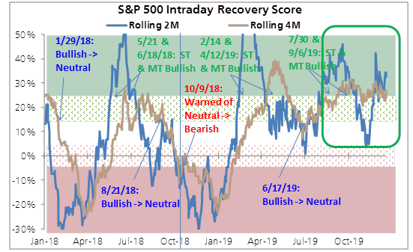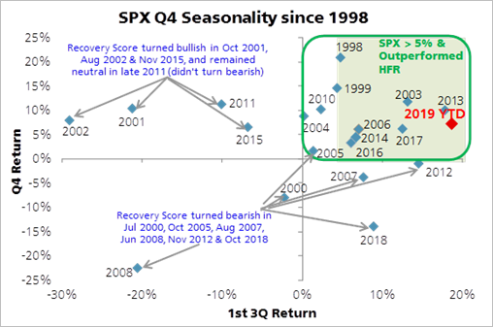

**Figures 9 & 10**

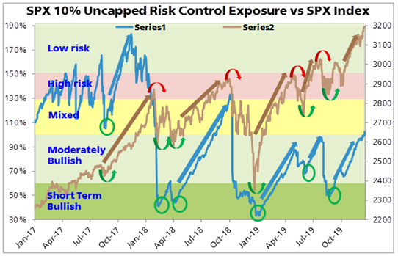 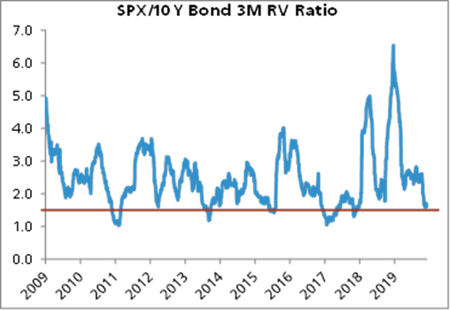

**Figure 11**

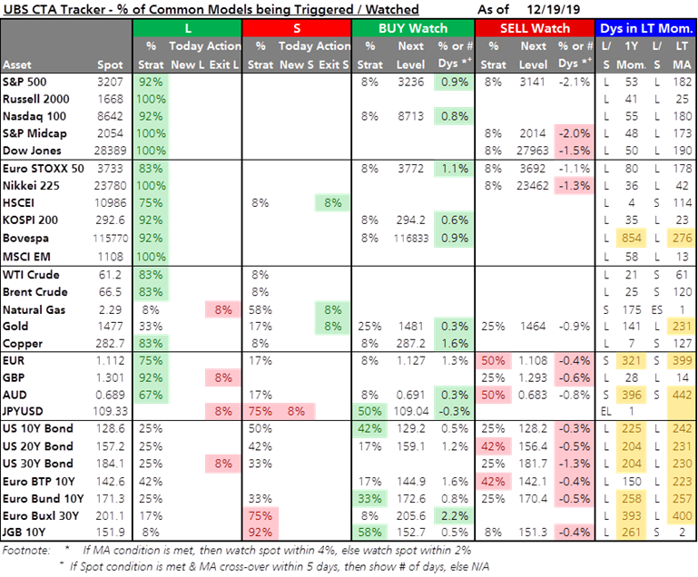

**Figures 12 & 13**

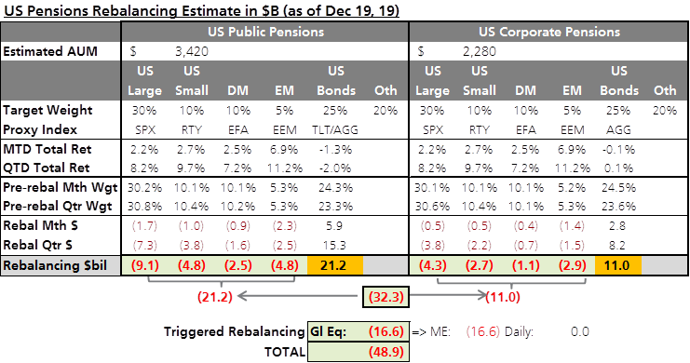

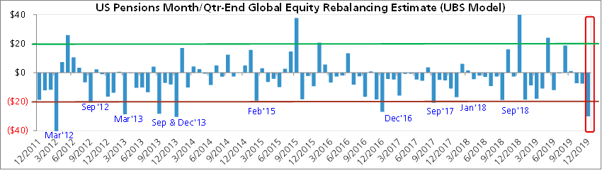

**Figures 14 & 15**

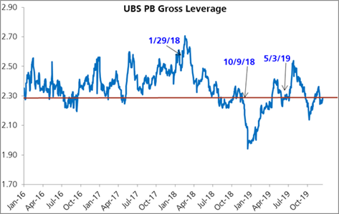  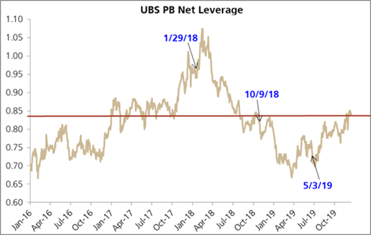

**Figures 16 & 17**

## 20200228 Fed emergency cut (AL, IOmar, Jelf Tomas):

Super helpful thanks.



**From:** Jelf, Tomas  
**Sent:** 28 February 2020 20:16  
**To:** Brodie, Joshua; Law, Andrew; Barrett, Iomar; Metsovitis, Efstathios; Gloster, Gary; Mazurek, Nicholas; Flow-HeadlineNews  
**Subject:** RE: *POWELL: MONITORING VIRUS, WILL USE TOOLS AND ACT AS APPROPRIATE

Re Iomar’s q about days of coordinated action see below.

# Three examples of coordinated action:

# Oct 8 2008 – Wednesday (50bps cuts by Fed, ECB, BOE , SNB, BOC, Rix)

# Nov 30 2011 – Wednesday (lower swap line rates by 50bps. Fed, BOC, BOE, BOJ, ECB, SNB)

# Oct 31 2013 – Thursday (swap lines made permanent)

# 

# Prior intra meeting cuts by the Fed:

# Oct 15 1998 – Thursday

# Jan 3 2001 – Wednesday

# April 18 2001 – Wednesday

# Sep 17 2001 – Monday

# Jan 22 2008 – Tuesday

# Oct 8 2008 - Wednesday

**From:** Brodie, Joshua  
**Sent:** 28 February 2020 20:11  
**To:** Law, Andrew; Barrett, Iomar; Metsovitis, Efstathios; Jelf, Tomas; Gloster, Gary; Mazurek, Nicholas; Flow-HeadlineNews  
**Subject:** RE: *POWELL: MONITORING VIRUS, WILL USE TOOLS AND ACT AS APPROPRIATE

Not sure if relevant given Powell’s statement afterwards.  But this was part of Bullard’s speech earlier:

*BULLARD: WE WILL WANT TO MONITOR EVENTS RIGHT UP UNTIL MEETING

**From:** Law, Andrew  
**Sent:** Friday, February 28, 2020 3:10 PM  
**To:** Barrett, Iomar; Metsovitis, Efstathios; Jelf, Tomas; Gloster, Gary; Mazurek, Nicholas; Flow-HeadlineNews  
**Subject:** Re: *POWELL: MONITORING VIRUS, WILL USE TOOLS AND ACT AS APPROPRIATE

Certainly the fed, and others if they want to join in.

**From:** Barrett, Iomar <ibarrett@caxton.com>  
**Sent:** Friday, February 28, 2020 8:08:20 PM  
**To:** Law, Andrew <ALaw@caxton.com>; Metsovitis, Efstathios <emetsovitis@caxton.com>; Jelf, Tomas <tjelf@caxton.com>; Gloster, Gary <ggloster@caxton.com>; Mazurek, Nicholas <nmazurek@caxton.com>; Flow-HeadlineNews <Flow-HeadlineNews@caxton.com>  
**Subject:** RE: *POWELL: MONITORING VIRUS, WILL USE TOOLS AND ACT AS APPROPRIATE

Thanks.

Do you mean broad buy in from other members on the FOMC, or from the other CBs (or both?).

**From:** Law, Andrew  
**Sent:** 28 February 2020 20:07  
**To:** Metsovitis, Efstathios; Barrett, Iomar; Jelf, Tomas; Gloster, Gary; Mazurek, Nicholas; Flow-HeadlineNews  
**Subject:** Re: *POWELL: MONITORING VIRUS, WILL USE TOOLS AND ACT AS APPROPRIATE

If they decide in coming days that’s what they need then they’ll do it immediately in my opinion. Needs broad buy in, not smoke and mirrors.

They prefer to wait.

**From:** Metsovitis, Efstathios <emetsovitis@caxton.com>  
**Sent:** Friday, February 28, 2020 8:04:41 PM  
**To:** Law, Andrew <ALaw@caxton.com>; Barrett, Iomar <ibarrett@caxton.com>; Jelf, Tomas <tjelf@caxton.com>; Gloster, Gary <ggloster@caxton.com>; Mazurek, Nicholas <nmazurek@caxton.com>; Flow-HeadlineNews <Flow-HeadlineNews@caxton.com>  
**Subject:** RE: *POWELL: MONITORING VIRUS, WILL USE TOOLS AND ACT AS APPROPRIATE

For devil’s advocate argument:

he could put clarida on TV to essentially preannounce “significant” (aka 50bp) march meeting action, at which venue they can explain thoroughly their reasoning given it’s a SEP meeting?

**From:** Law, Andrew  
**Sent:** 28 February 2020 20:02  
**To:** Barrett, Iomar; Jelf, Tomas; Gloster, Gary; Mazurek, Nicholas; Flow-HeadlineNews  
**Subject:** Re: *POWELL: MONITORING VIRUS, WILL USE TOOLS AND ACT AS APPROPRIATE

Not immediately. Market reaction will determine that in the coming days.

If it comes either 11am or around 1pm london time.

**From:** Barrett, Iomar <ibarrett@caxton.com>  
**Sent:** Friday, February 28, 2020 7:48:00 PM  
**To:** Jelf, Tomas <tjelf@caxton.com>; Gloster, Gary <ggloster@caxton.com>; Mazurek, Nicholas <nmazurek@caxton.com>; Flow-HeadlineNews <Flow-HeadlineNews@caxton.com>  
**Subject:** RE: *POWELL: MONITORING VIRUS, WILL USE TOOLS AND ACT AS APPROPRIATE

When would we expect emergency coordinated policy action if it were to come? Is it historically over a weekend? Ive totally forgotten the emergency CB playbook.

**From:** Jelf, Tomas  
**Sent:** 28 February 2020 19:45  
**To:** Gloster, Gary; Mazurek, Nicholas; Flow-HeadlineNews  
**Subject:** RE: *POWELL: MONITORING VIRUS, WILL USE TOOLS AND ACT AS APPROPRIATE

In case anyone forgot ‘act as appropriate’ is of course the words used before each of last year’s rate cuts.

Questions now are 1) if they think this preannouncement buys them time to March 18th, and 2) how large the cut will be.

It would be surprising to me if they concluded that 1) this sort of emergency statement is needed and 2) concluded that they can still wait.

If that is nevertheless their thinking the bar for cutting is now made very low.

**From:** Jelf, Tomas  
**Sent:** 28 February 2020 19:33  
**To:** Gloster, Gary; Mazurek, Nicholas; Flow-HeadlineNews  
**Subject:** RE: *POWELL: MONITORING VIRUS, WILL USE TOOLS AND ACT AS APPROPRIATE

This is the statement

**From:** Gloster, Gary  
**Sent:** 28 February 2020 19:32  
**To:** Mazurek, Nicholas; Flow-HeadlineNews  
**Subject:** RE: *POWELL: MONITORING VIRUS, WILL USE TOOLS AND ACT AS APPROPRIATE

Powell Says Monitoring Virus, Will Use Tools, Act as Appropriate  
  
  
By Craig Torres  
(Bloomberg) -- Federal Reserve Chairman Jerome Powell said  
the coronavirus “poses evolving risks” to U.S. growth and  
signaled the central bank is prepared to cut interest rates if  
necessary to support the expansion.  
The statement issued by Powell before the financial markets  
closed for the U.S. weekend comes as stocks were in their  
seventh-straight loss, prompting calls for near-term interest  
rate cuts from Wall Street banks. Yields on U.S. Treasury  
securities, one of the world’s safest assets, have fallen to  
record lows.  
“The fundamentals of the U.S. economy remain strong,”  
Powell said in the statement Friday. “However, the coronavirus  
poses evolving risks to economic activity. The Federal Reserve  
is closely monitoring developments and their implications for  
the economic outlook. We will use our tools and act as  
appropriate to support the economy.”  
Fed officials in recent days have pushed back somewhat on  
the idea of an emergency rate cut saying there was too much  
uncertainty. Meanwhile, economists have been lowering their  
forecasts for both global and U.S. growth.

**From:** Mazurek, Nicholas <nmazurek@caxton.com>  
**Sent:** Friday, February 28, 2020 2:31 PM  
**To:** Flow-HeadlineNews <Flow-HeadlineNews@caxton.com>  
**Subject:** *POWELL: MONITORING VIRUS, WILL USE TOOLS AND ACT AS APPROPRIATE

*POWELL: MONITORING VIRUS, WILL USE TOOLS AND ACT AS APPROPRIATE

*POWELL SAYS `FUNDAMENTALS OF THE U.S. ECONOMY REMAIN STRONG'

*POWELL SAYS VIRUS POSES EVOLVING RISKS TO ECONOMIC ACTIVITY

*FED CHAIR POWELL ISSUES STATEMENT ON CORONAVIRUS

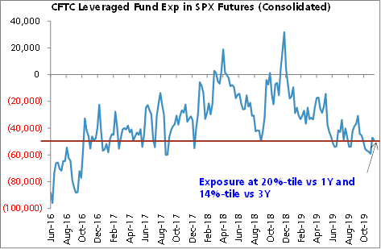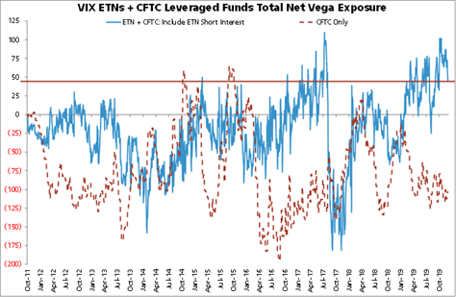

**Figures 18 & 19**

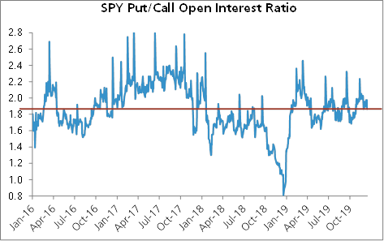  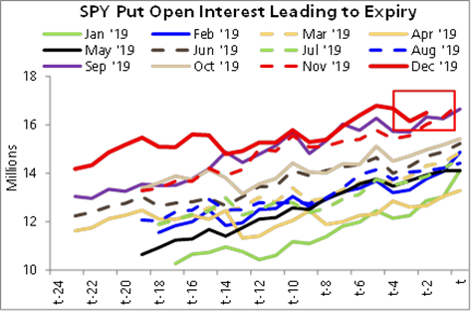

**Figure 20**

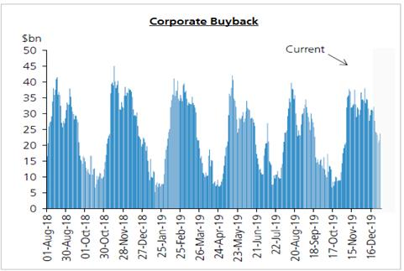

Sources: UBS & Bloomberg

-----Original Message-----

From: Thomas, Dale

Sent: 07 March 2019 20:42

To: FX Team; Barrett, Iomar

Subject: Economic Progress Report: Sensible Shifts in Household Spending - Bank of Canada

https://www.bankofcanada.ca/2019/03/economic-progress-report-sensible-shifts-in-household-spending/

For the Canada nerds out there. This is BoC Dep Gov Lynn Patterson's speech today in which she expanded on the BoC decision. My take is that is even more dovish than the statement. Her conclusion was

"Although we figured the economy was in for a detour at the end of last year, that detour may wind up being longer than we had expected. It now appears the economy will be weaker in the first half of 2019 than we had projected in January. However, we still expect Canadian economic growth to pick up later in the year, supported by ongoing strength in employment and rising wages. We will have more to say in April, when we will have a new economic projection, as well as our annual updated estimates for economic potential and the neutral interest rate.

At yesterday’s decision, Governing Council judged that the outlook continues to warrant a policy interest rate that is below its neutral range. Given the mixed picture that the data present, it will take time to gauge the persistence of below-potential growth and the implications for the inflation outlook. With increased uncertainty about the timing of future rate increases, Governing Council will be watching closely developments in household spending, oil markets and global trade policy"

In the Q&A she apparently said " BANK STAFF IS LOOKING TO SEE IF THE NEUTRAL RATE RANGE NEEDS TO CHANGE". It would be no surprise if in April the BoC lowered its neutral rate to something that is magically close to the current nominal rate. Meaning they can retire the last vestige of hawkishness, the " With increased uncertainty about the timing of future rate increases," line.

**From:** Thomas, Dale   
**Sent:** 01 April 2019 20:19  
**To:** Gloster, Gary; Flow-Prices  
**Subject:** RE: Prices / Poloz

The conclusion was the only mildly Interesting bit

That being said, it is clear that the global economy is performing less well than we believed only a few months ago, and Canada is feeling the effects. In addition, our housing sector is taking longer than previously expected to digest the combined effects of stricter mortgage guidelines and higher interest rates.

That is why we said at our last interest rate announcement in March that the economic outlook continues to warrant a policy interest rate that is below the neutral range, to help the economy work through this downshift in growth and keep inflation close to target. Recent economic data have been generally consistent with our expectation that the period of below-potential growth will prove to be temporary.

Our next interest rate announcement and *Monetary Policy Report* will be released on April 24, and I can promise a fuller analysis at that time. For now, let me thank you for your kind attention, and for your wonderful hospitality here in Iqaluit.

  .He missed out the line about needing rates to eventually rise to neutral

**From:** Gloster, Gary   
**Sent:** 01 April 2019 19:57  
**To:** Flow-Prices  
**Subject:** Prices / Poloz

*DATA SHOW `MIXED PICTURE,' MUST BE CAREFULLY MONITORED: POLOZ

*BANK OF CANADA GOVERNOR POLOZ GIVES SPEECH IN IQALUIT, NUNAVUT

*EXPORT, INVESTMENT GROWTH TO TURN POSITIVE THIS YEAR: POLOZ

*RECENT DATA CONSISTENT WITH TRANSITORY SLOWDOWN VIEW: POLOZ

*POLOZ SEES `MANY AREAS' OF ENCOURAGING ECONOMIC GROWTH

*OIL SECTOR CONTINUES TO ADJUST TO LOWER PRICES, POLOZ SAYS

*HOUSING SECTOR TAKING LONGER TO DIGEST NEW RULES, RATES: POLOZ

*POLOZ SEES `CLEAR SIGNS' CANADA IS ADJUSTING TO CHALLENGES

*POLOZ SAYS PERIOD OF BELOW-POTENTIAL GROWTH WILL BE TRANSITORY

*POLOZ: OUTLOOK CONTINUES TO WARRANT RATES BELOW NEUTRAL RANGE

**From:** Thomas, Dale   
**Sent:** 28 February 2019 17:04  
**To:** meetingsFX  
**Subject:** For FX meeting tomorrow - FX impact of Fed running cpi at 2.3% in order to meet its 2% inflation target

**FX impact of Fed running cpi at 2.3% in order to meet its 2%  inflation target?**

**The long term impact is unclear**

**Conceptual issues**

For a start, conceptually the Fed is doing nothing new, its simply trying to meet its 2% inflation target. There is no suggestion of this changing its inflation target. If the Fed succeeds, then the end result will be a tightening to get inflation from 2.3% to 2%. So there should be no change to the terminal USD forward rate. Working backwards, any move in spot USD will therefore be limited to the kneejerk move lower.  This is not the same as the JPY experience in 2015.  Then there is the reality that  USD moves are driven by changes in economy wide real interest rates  which we cannot observe but can infer. Would a slight (50bp) easing lead to higher or lower economy wide real returns ?

**Fed fund and the USD - history**

First of all the link between Fed policy and the USD is unclear.  If things are soggy enough globally for the Fed cuts rates, we can assume there will be a policy response in the same direction, so this is not the 2005/2007 scenario.  Also, in terms of the recent cycle, the peak in the USD was when Fed funds was 0.625%. Market has been trading the end of the cycle since then.  After an easing, is it going to play the start of the next cycle.  ?

**Fed Funds and the curve**

**Spot the correlation and the causation  ?**

Relative curve shapes have had some influence on EURUSD recently.  If the US curve steepens and the EU curve flattens, does EURUSD go up or down ?

**Running the economy hot and the USD.**

The snakeoil salesmen on the sell side love the expression “running the economy hot”, without  defining what that means.  I would define it as running ex-ante nominal aggregate demand growth ahead of ex-ante nominal supply.  In the world we are in of excess supply (which is why), this means a mix of higher prices and demand leaking overseas. A policy like this should lead to a persistent negative contribution to GDP growth from net exports. Periods of consecutively negative net exports contributions have typically been associated with a higher not a lower USD. And vice versa.  On the capital side, higher nominal demand attracts excess foreign capital.  So running the economy hot means attracting foreign capital which means a stronger USD ?

Bottom line, we cannot complete this sentence with any confidence, “if the fed targets 2.3% CPI for a few years as a way of ensuring its long term target of 2%, the USD will………”

**From:** Tezgul, Mehmet   
**Sent:** 11 March 2019 11:21  
**To:** Adyel, Selim; Bae, Che-Hwon; Biri, Eren; Cisneros, Diego; Cole, Peter; Gloster, Gary; Jelf, Tomas; Kraft, Stuart; Kunur, Omkar; Kurella, Vishnu; Law, Andrew; Linden, Denise; McQuaid, Stuart; Mehta, Mudit; Mittal, Sugandh; Mittal, Vibhor; Mohammad, Junaid; Ng, Shaun; Peck, Matthew; Reddy, Abhishek; Rishi, Tim; Rowe, Aaron; Slade Perry, Charlotte; Sod Hoffs, Gabriel; Thomas, Dale; Turton, Felix; van 't Klooster, Pieter; Wade, Matthew; Yang, Justin  
**Subject:** Btwn the lines from 60min interview - RE: XAUUSD & Change in FED Inflation Targeting

There will be months of debate on this but below excerpt the most critical in what the chair thinks currently: “We haven’t actually said that we want to average 2% inflation.”

Sounds like they *will not actively* pursue average inflation targeting but making sure errors are two way to arrest the lower drift in inflation expectations, which is the main problem – deflation & inflation risks are symmetric.

In theory symmetrically random errors would mean averaging 2% inflation. But errors are anything but normal at the moment – maybe structurally so.

Or is this just semantics and Powell trying to calm down the discussion?

Any thoughts most appreciated.

POWELL: We haven't actually said that we want to average 2% inflation. What we've said is something a little bit different, which is that we look at errors above and below 2% symmetrically. Honestly though, inflation has mostly been below 2%. We haven't had inflation above 2%. And so it has averaged less than 2%. And that's something that is worth thinking about because we want inflation expectations to be anchored at around 2%. And we have to reach 2% sustainably and symmetrically we think for that to be the case in the long run.

PELLEY: Want to make sure I understand. If the inflation rate rises something over 2% for a limited period of time, that doesn't mean the Fed's going to jump on the brakes?

POWELL: I think we wouldn't overreact to inflation modestly above 2% any more than we overreacted to inflation modestly below 2%. I think we'll always be moving inflation back to 2% with our policy. But I think we do that in a symmetric way.

**From:** Tezgul, Mehmet   
**Sent:** 01 March 2019 15:10  
**To:** Adyel, Selim; Bae, Che-Hwon; Biri, Eren; Cisneros, Diego; Cole, Peter; Gloster, Gary; Jelf, Tomas; Kraft, Stuart; Kunur, Omkar; Kurella, Vishnu; Law, Andrew; Linden, Denise; McQuaid, Stuart; Mehta, Mudit; Mittal, Sugandh; Mittal, Vibhor; Mohammad, Junaid; Ng, Shaun; Peck, Matthew; Reddy, Abhishek; Rishi, Tim; Rowe, Aaron; Slade Perry, Charlotte; Sod Hoffs, Gabriel; Tezgul, Mehmet; Thomas, Dale; Turton, Felix; van 't Klooster, Pieter; Wade, Matthew; Yang, Justin  
**Subject:** XAUUSD & Change in FED Inflation Targeting

W/r to XAUUSD the framework is simple so I planned to talk about it. Given we ran out of time, however, please find my thoughts below:

**The potential adjustment to inflation targeting approach discussed at the FED, if implemented, could have significant, bullish implications for XAUUSD. The range of potential outcomes is very wide. As floor and cap one could quantify the following two**(based on the classical frame work of pricing XAUUSD based on USD (JPMQUSD) and real rates (USGGT10Y;) 70-80% R-squared):

In this framework, the stable channel is via real rates, for each 1bsp move in real rate, appx impact on XAUUSD is 1.5-3usd. (I am looking to estimate this more precisely but not much progress yet; might be a polynomial fit.)

Change in USD, though in the regression, is assumed to be 0.

**Scenario 1, floor – min impact**(similar to what Dale was envisioning)

FED overshoots for 1 year (appeases Trump w/ hot economy) but backtracks.

~50bsp ➔ 100usd

**Scenario 2, cap –max impact**

FED makes up for the cumulative inflation missed for ~10y, overshooting its target by a similar amount over the course of next 10 years.

Appx. cumulative miss is  ~800bs ➔ 1600 – gold price doubles – 160usd + drift per year.

**If the policy change comes through I believe the reality will be something in between.**

**Other considerations:**

a) I agree USD impact is unclear as fx is a relative process. Thus, I assume no impact from USD here. Saying that, assuming CBs follow FED conceptually, and change their mandates from effective caps to symmetric averages, I believe impact on XAU in all fiat currencies would be materially positive.

b) Short-term, the reason I remained lukewarm to XAUUSD YTD was expectations of bounce in Chinese activity stabilizing global g and thus, potential for real rates to reprice a degree of hikes. I believe, even if the bounce in g materializes now, given the discussion on inflation targeting framework, it is likely that breakevens absorb such change w/ real rates remaining suppressed. Possibly takes out the downside in XAUUSD.

c) An argument for slow pricing of the policy change is “how will we know” argument. Right now we are at 1.9%. We need to somehow get above towards 2.3-2.5% for market believe the permanency of the change credibly. (What confuses people is, even though the language is not changing, until now the symmetric target was an aspirational goal which you never reach, market might want to see evidence to change this perception. As Andrew said, FED needs to do something itself to get there given the outlook/structural drag. Without that, even if they change policy, we would not have a chance to test the reaction function. Thus, this might be a slow burn.

d) Pricing of the **Scenario 2, cap –max impact**does not need to happen in 10 years as market prices ahead structurally higher inflation expectations. I do not want to sound sensational here but, for fiat currency and hard asset pricing, this debate is much more important than the pause or the balance sheet discussions in my opinion.

e) As mentioned in the meeting, a) Powell seems intend defining the issue a “problem” and effort a “public duty”, b) micro economic framework is robust (Friedman), and c) only part of the inflation conundrum they have control over (vs other theories out there about demographics/savings, technology, China/globalisation.)

f) I think this a 3rd dovish debate FED has opened this year in addition the pause and balance sheet.

**From:** Thomas, Dale   
**Sent:** 23 March 2019 11:40  
**To:** Mittal, Sugandh; Tezgul, Mehmet; Law, Andrew; Desk  
**Subject:** RE: [EXTERNAL] Andrew-- take a look--Charts on Fed Recession Model***

A few thoughts on this

•         Plenty of literature that points to global QE having had a significant impact on term premium on the “global” yield curve, so these curve models probably overstate the recession probability

•         I don’t see the domestic private sector imbalances in the US economy that presaged previous recessions; excess business investment in 1999/2000 and  the consumer debt binge in the mid 2000s. The US is at little danger of a domestic led recession at the moment

•         In the EM world (and DM dependant on EM growth countries), which has been the epicentre of credit reflation since 2008, there are clear recessionary signs as private sector savings rate rise. The private sector in China is in a recessionary period for example

•         The Fed de jure sets rates and influences credit conditions for the USA, de facto it does so for most of the EM world including China.  Given the share of EM activity in the global economy has grown so much in recent years, the Fed’s sphere of influence may well be the largest, in terms of share of global GDP, than it ever has been.

•         Fed policy seems to be just right for the US,  but too tight for the rest of the Dollar area.  The weakness in EMFX in the last few days is a warning sign of this. I am monitoring this carefully.    The flat yield curve may well be signalling a further slowdown in the broader USD economic area.

•         At the same time, risks outside of the USD block are rising. European leading indicators are hinting that the slowdown in external demand  is about to feed through into job losses. The risks to the downside are growing

•         2.5% is not a magic number. It just happens to be where Fed funds are right now. Given global developments, both in the broader USD area and in Europe, Fed funds rate looks too high.

•         Interestingly, the probability of recession reached the same level in 1998. The economic constellation looks very similar to today. Strong domestic demand in the US, weak growth and financial crises elsewhere. The Fed eventually cut rates by 75bps to stabilise things, extending the life of the expansion by 2 to 3 years.  I still think this is the closest historical parallel with today

**From:** Mittal, Sugandh   
**Sent:** 23 March 2019 05:33  
**To:** Tezgul, Mehmet; Law, Andrew; Desk  
**Subject:** RE: [EXTERNAL] Andrew-- take a look--Charts on Fed Recession Model***

Market’s own assessment of US recession is much lower than 53%.

Taking 3 scenarios in which 1) the Fed hikes 25bp, 2) be on hold or 3) cuts back to 0.25% in case of a recession, I only get a **20%** probability of recession.

In other words, if one believes the recession probability is 53%, we should be pricing in 120bp cuts instead of the 45bp in this cycle.

|  |  |  |
| --- | --- | --- |
| Scenarios | Probability | Fed hikes/cuts |
| Scenario 1: Global growth stabilizes; US core CPI >2.2%; Europe/China surprise upside | ***5%*** | +25 |
| Scenario 2: Global growth stabilizes; US core CPI hovers below 2%; no major stimulus from China | ***75%*** | 0 |
| Scenario 3: US recession | ***20%*** | -225 |
|  |  |  |
| Weighted average of cuts priced in (to equate to current market pricing in this cycle) |  | -44 |

**From:** Tezgul, Mehmet   
**Sent:** 23 March 2019 03:05  
**To:** Law, Andrew; Desk  
**Subject:** RE: [EXTERNAL] Andrew-- take a look--Charts on Fed Recession Model***

1) I keep hearing “the decline in term premium this time makes inversion less of a signal.”

I guess near-term forward spreads incorporate less term premium and thus, less susceptible to above counterargument. Would you agree?

2) Beyond 40% probability it looks like there has been one success story of no-recession - 1998-99 episode. Prescient that Powell’s Jackson Whole speech focused on this episode – see below. (Cannot explain why/how Powell pivoted hawkish after this speech in Aug until Dec.) Where will the positive productivity shock going to come from this time?

**Shifting Stars and the "New Economy" of the Late 1990s**  
The second half of the 1990s confronted policymakers with a situation that was in some ways the flipside of that in the Great Inflation. In mid-1996, the unemployment rate was below the natural rate as perceived in real time, and many FOMC participants and others were forecasting growth above the economy's potential. Sentiment was building on the FOMC to raise the federal funds rate to head off the risk of rising inflation.[9](https://www.federalreserve.gov/newsevents/speech/powell20180824a.htm#fn9) But Chairman Greenspan had a hunch that the United States was experiencing the wonders of a "new economy" in which improved productivity growth would allow faster output growth and lower unemployment, without serious inflation risks. Greenspan argued that the FOMC should hold off on rate increases.

Over the next two years, thanks to his considerable fortitude, Greenspan prevailed, and the FOMC raised the federal funds rate only once from mid-1996 through late 1998.[10](https://www.federalreserve.gov/newsevents/speech/powell20180824a.htm#fn10) Starting in 1996, the economy boomed and the unemployment rate fell, but, contrary to conventional wisdom at the time, inflation fell.[11](https://www.federalreserve.gov/newsevents/speech/powell20180824a.htm#fn11)

Once again, shifting stars help explain the performance of inflation, which many had seen as a puzzle. Whereas during the Great Inflation period the real-time natural rate of unemployment had been well below our current-day assessment, in the new-economy period, this relation was reversed (figure 3). The labor market looked to be tight and getting tighter in real time, but in retrospect, we estimate that there was slack in the labor market in 1996 and early 1997, and the labor market only tightened appreciably through 1998 (figure 4). Greenspan was also right that the potential growth rate had shifted up. With hindsight, we recognize today that higher potential growth could accommodate the very strong growth that actually materialized, let alone the moderate growth policymakers were forecasting.[12](https://www.federalreserve.gov/newsevents/speech/powell20180824a.htm#fn12)

The FOMC thus avoided the Great-Inflation-era mistake of overemphasizing imprecise estimates of the stars. Under Chairman Greenspan's leadership, the Committee converged on a risk-management strategy that can be distilled into a simple request: Let's wait one more meeting; if there are clearer signs of inflation, we will commence tightening.[13](https://www.federalreserve.gov/newsevents/speech/powell20180824a.htm#fn13) Meeting after meeting, the Committee held off on rate increases while believing that signs of rising inflation would soon appear. And meeting after meeting, inflation gradually declined.

In retrospect, it may seem odd that it took great fortitude to defend "let's wait one more meeting," given that inflation was low and falling. Conventional wisdom at the time, however, still urged policymakers to respond preemptively to inflation risk--even when that risk was gleaned mainly from hazy, real-time assessments of the stars. With the experience in the new-economy period, policymakers were beginning to appreciate that, with inflation expectations much better anchored than before, there was a smaller risk that an inflation uptick under Greenspan's "wait and see" approach would become a significant problem.

**From:** Law, Andrew   
**Sent:** 22 March 2019 18:40  
**To:** Desk  
**Subject:** Fwd: [EXTERNAL] Andrew-- take a look--Charts on Fed Recession Model***

Begin forwarded message

Here are charts from the recession model:

The model (described [in this Fed post here](https://nam03.safelinks.protection.outlook.com/?url=https%3A%2F%2Fwww.federalreserve.gov%2Feconres%2Fnotes%2Ffeds-notes%2Fdont-fear-the-yield-curve-20180628.htm&data=02%7C01%7CALaw%40caxton.com%7Ca6fc5491fa3841f6056e08d6aef00ced%7C70c99524736c49f4b73e75d7fa126cf9%7C0%7C0%7C636888743373080108&sdata=WE6RkYjtRvgdyA9qurJv7Y7s5uTfRP%2FMKKwcK%2BFT7b8%3D&reserved=0)) uses a near-term forward spread as a proxy for market expectations of Fed policy to estimate recession probabilities.

The near-term forward spread – estimated here by interpolating between the 1y3m and 2y3m forward UST rates and taking the spread versus spot 3m T-bills – currently stands at -30bp, a low since January 2008.

Based on the Fed staff’s recession probability model [referenced in this morning’s WSJ article](https://nam03.safelinks.protection.outlook.com/?url=https%3A%2F%2Fwww.wsj.com%2Farticles%2Fanalysis-fed-chairman-jerome-powell-shows-his-flexible-side-11553247000%3Fmod%3Dhp_lead_pos6&data=02%7C01%7CALaw%40caxton.com%7Ca6fc5491fa3841f6056e08d6aef00ced%7C70c99524736c49f4b73e75d7fa126cf9%7C0%7C0%7C636888743373090113&sdata=hbndDMQlWdD2%2FPHfntEJ0IXa2pN5wHcukOyIhhoQXaA%3D&reserved=0), **the model gives a recession probability of 53%.**

Robert Rosener, Vice President     
**Morgan Stanley | Research**1585 Broadway, 38th Floor | New York, NY  10036     
Phone: +1 212 296-5614     
[Robert.Rosener@morganstanley.com](mailto:Robert.Rosener@morganstanley.com)     
  
Morgan Stanley’s US Economics team has been awarded the 2018 Blue Chip Lawrence R. Klein Award for the most accurate forecasts over the past 4 years. Read the press release [here.](https://nam03.safelinks.protection.outlook.com/?url=https%3A%2F%2Fwww.prnewswire.com%2Fnews-releases%2Feconomic-growth-expected-to-slow-significantly-in-2019-chief-us-economist-ellen-zentner-of-morgan-stanley-wins-lawrence-r-klein-award-for-forecasting-accuracy-300715543.html&data=02%7C01%7CALaw%40caxton.com%7Ca6fc5491fa3841f6056e08d6aef00ced%7C70c99524736c49f4b73e75d7fa126cf9%7C0%7C0%7C636888743373100123&sdata=8trUSQa4kNPp%2BNGk0yFa4yyjmr%2BhKdl3SOlfElm2eMY%3D&reserved=0)  
     
     
Be carbon conscious. Please consider our environment before printing this email.    

This is sales and trading commentary prepared for institutional investors; it is NOT a research report; tax, legal, financial, or accounting advice; or an official confirm. The views of the author may differ from others at MS (including MS Research). MS may engage in conflicting activities -- including principal trading before or after sending these views -- market making, lending, and the provision of investment banking or other services related to instruments/issuers mentioned. No investment decision should be made in reliance on this material, which is condensed and incomplete; does not include all risk factors or other matters that may be material; does not take into account your investment objectives, financial conditions, or needs; and is not a personal recommendation or investment advice or a basis to consider MS to be a fiduciary or municipal or other type of advisor. It constitutes an invitation to consider entering into derivatives transactions under CFTC Rules 1.71 and 23.605 (where applicable) but is not a binding offer to buy or sell any financial instrument or enter into any transaction. It is based upon sources believed to be reliable (but no representation of accuracy or completeness is made) and is likely to change without notice. Any price levels are indicative only and not intended for use by third parties. Subject to additional terms at <http://www.morganstanley.com/disclaimers/productspecific.html>.  By communicating with MS, you acknowledge understanding of, and consent to, the foregoing and to the voice recording of telephone conversations with personnel of Morgan Stanley.

**From:** Thomas, Dale   
**Sent:** 09 April 2019 16:16  
**To:** Jelf, Tomas; Law, Andrew; Desk  
**Subject:** RE: job openings

Quit rates are high, but may be peaking while discharge rates are at cycle lows, as is unsurprisingly the jobless claims rate    Firms are not firing and employees are not afraid to quit to look for other jobs.  At the same time,  weakness in the internals of the job report and the weak hiring components of the NFIB survey point to a fall off in labour demand.

**From:** Jelf, Tomas   
**Sent:** 09 April 2019 15:29  
**To:** Law, Andrew; Desk  
**Subject:** RE: job openings

Third largest drop on record. What’s unusual is that it doesn’t follow a large increase in the prior month. See chart below.

That said, even if this is the peak a recession may be far off. E.g. in the prior cycle job openings peaked 20 months before the recession.

That peak coincided with the first top in the pre-2008 double top in yields while equities continued to move higher. See chart below.

Only one event so the observation has to be treated as such.

**From:** Law, Andrew   
**Sent:** 09 April 2019 15:01  
**To:** Desk  
**Subject:** job openings

**From:** Thomas, Dale   
**Sent:** 15 April 2019 15:00  
**To:** FX Team  
**Subject:** MXN longs on IMM have got to elevated levels

Interesting that MXN net spec longs on IMM are as long as they have ever been, with considerable length added over the last month.  IMM data needs to be taken with a pinch of salt and with MXN having the best carry to vol ratio of any liquid EM currency it is no surprise that the IMM position is large, nonetheless it suggests there has been a large build-up of EMFX longs in Q1 to levels that historically have been unsustainable.

**From:** Thomas, Dale   
**Sent:** 16 April 2019 11:02  
**To:** Desk  
**Subject:** RE:

Charts by Macquarie also highlight the fiscal stimulus as well as where the main changes in TDF were.  Chinese have really thrown the kitchen sink at this, despite subdued end-user demand for cresit

|  |  |  |
| --- | --- | --- |
|  |  |  |
| |  |  |  | | --- | --- | --- | |  |  |  | | Source: CEIC, Macquarie Macro Strategy, April 2019 |  |  | |  |  |
| Source: CEIC, Macquarie Macro Strategy, April 2019 |  | Source: CEIC, Wind, Macquarie Macro Strategy, April 2019 |

**From:** Tezgul, Mehmet   
**Sent:** 16 April 2019 08:09  
**To:** Law, Andrew; Desk  
**Subject:** RE:

*CHINA 1Q FISCAL SPENDING RISES 15% Y/Y, MOF SAYS

Neither the Local Gov/other off-balance sheet items nor the VAT/social sec payment/fee cuts would be included here.

**From:** Law, Andrew   
**Sent:** 16 April 2019 07:39  
**To:** Desk  
**Subject:**

CNY rates back-up now approaching similar post-stimulus one in q2 2016

**From:** Thomas, Dale   
**Sent:** 24 April 2019 11:41  
**To:** FX Team  
**Subject:** USD upside vs EM - Early contribution to FX meeting on Friday

**Early contribution as I am away for the rest of the week**

**USD upside vs EM, commodity currencies**

Rationale

•         On the economic front, the bottom line is that better China growth trajectory is priced in, with a high bar for near-term positive surprises; growth in the high yielding EM countries is awful and not getting any better.  Taiwan and Korea are not bouncing.   Final demand growth in US and EU seems to have transitioned from well above potential to around potential.  The key global inflation reading, China PPI points to further disinflation.   Taken all together, is seems that global growth has stabilized at lower levels with no sign of an aggressive bounce-back.  This will eventually put further downward pressure on global inflation, which is already too low  So-so growth in the EU and US is just not good enough to create inflation, while the rest of the world is exporting disinflation.

•         As far as markets go, there has been large buying on EM markets despite an unsupportive growth environment.  US dollar cash continues to be a high performing asset in return to risk terms.  Negative USD sentiment is widespread.  European and EM Asia stocks have already priced in a strong cyclical rebound.

•         Clear opportunity for the USD to outperform vs EM and US assets in general to outperform EM assets

 There are also implications for other markets.  A stronger USD would (justifiably ) be taken as a sign US policy is too tight,   With a weakish global backdrop, the US and EU authorities need to target final demand growth well above trend to hit their inflation targets.  For now, they can hope that the rebound in financial conditions may work some magic, but if it does not the authorities will have to boost stimulus. Rate cuts are likely to come into the front end of all curves

**ECONOMY**

**Chinese data better to travel than arrive**

Chinese data was always likely to be strong, given the very late LNY and an aggressive push to create short term credit in the finance system.  But that is more than fully priced now.  There is  a very high bar for Chinese April and May data to beat expectations.  Longer term, the boost in TSF is unsustainable without an sharp increase in housing credit, which would challenge the structural deleveraging dynamic.

**PMI Seasonal pattern is for softness until Q3**

In China, as everywhere growth in home loans is needed to drive credit growth on a sustainable basis

Substantial credit explosion will lead to large C/A deficit

Inflation leading indicator heading lower

**HY EM very weak**

As for the rest of the world. It is clear that the major EM economies are all in bad place with weak growth on both the supply side and the demand side.  All these economies are still in a deleveraging mode after the credit binge post 2006.  Current accounts are heading into surplus as net national savings rates rise.   These countries will import growth on a marginal basis from the rest of the world, a structural recipe for weak currencies.

Chart of IP growth

No recovery in NE ASIA

Mediocre final demand growth in EU and US.  More mediocre in EU , less mediocre in US, but mediocre nonetheless

Final demand growth in the EU and US seems to have stepped  down to a 2% level in Q4, and there of just below in Q1.  There seems little reason to expect a recovery in Europe in q3.  In the US, the broad sweep of data is a bit more positive, and spare capacity is lower.   The USA remains the best looking pig in the st. A decent working assumption is that final demand will not  move much from here,.   Inflation will continue to head lower in this environment

**Markets -**

There has been significant accumulation of EM and EM related assets in recent months.

Imm MXN SPEC LONGS VS MXNUSD

Risk reversals back to last summer level

Europe automakers vis zew current conditions

Technical

So far USD just going sideways

**From:** Thomas, Dale   
**Sent:** 13 May 2019 10:39  
**To:** FX Team  
**Subject:** Housing bubble in Australia continues to delfate

The Australian housing bubble continues to deflate.  A very poor reading on new home loans today.  Prices are likely to follow.  Declining home loan advances, declining prices will both weigh heavily on consumer spending.  There is every reason to expect a further deceleration in GDconsumer spending from the current level around  1.5% per annum.  RBA forecasts still too optimistic.  The obvious policy response to this ongoing decline in provate demand is an aggresive boost to fiscal spending but there is little sign of this. In its absence,  monetary policy/exchange rate will have to take up the slack

**From:** Thomas, Dale   
**Sent:** 15 May 2019 11:36  
**To:** meetingsFX  
**Subject:** USD outlook in US/China trade war environment- cor FX meeting

**Summary**

•         **Limited first round impact  USDCNY higher**

•         **Mildly USD positive 2nd round impact unless Europe is dragged in to trade wars, in which case it is very clear USD positive**

•         **USD largely range-bound until the global cycle turns up**

•         **USD negative and USD positive scenarios exist for the range break; trade wars make the positive one more likely**

•         **No sign that the muti-year USD bull market is over yet**

**Academic theory**

**First round impact**

IMF paper “Macro economic consequences of tariffs” is the best place to start.  <https://www.google.com/search?q=imf+impact+of+tarriffs&sourceid=ie7&rls=com.microsoft:en-GB:IE-Address&ie=&oe>=

First round impact is clear.  Higher tariffs lead to a near offsetting move in real exchange rates.  USDCNH should all other things being able move to reflect the change in tariffs.  This should lead to a small one off increase in the USD vs broader currencies.

**Second round impact of US/China tariff**

US/China tariffs will have a dampening impact on global activity in all regions. The relative impact of this is unclear. Europe seems more vulnerable to this than the US, given the higher export and manufacturing exposure but it does not seem enough to change relative supply and demand dynamics yet.

**Second round impact of US extending trade war to Europe**

This will be a clear negative for the European economy given the relative trade balance and Europe’s higher sensitivity to trade. EURUSD would have to adjust accordingly lower from both first round and second round effects

**Evidence of impact**

**Recent currency moves**

**Currencies indexed to 100 12 months ago**

Currency markets have become becalmed with very low levels of volatility and tight ranges. Evidence that the expected limited impact from tariffs has in fact been seen.  Seems unlikely to see much change in EURUSD until there is a change in global and relative economic momentum.  AUDUSD can continue its steady decline based on domestic factors.  Two possible exit regimes for  the USD, depending on which country leads the global economy out of the current inventory slowdown.  The key is to focus on which is most likely and how the trade war impacts the relative ex-ante probabilities of each option. For simplicity I have just focused on EURUSD.

**Future medium term USD trend**

**USD negative**

The three post GFC upturns have been led by EM and Europe, leading to upward pressure on EURUSD,  This is still  the consensus template for the next upturn. This requires one more bout of re-leveraging by EM countries in aggregate.  Given the weakness in Latam , Turkey and Africa, this really means China.  Any such episode will I think be a pale shadow of previous ones, but could still lead to a small USD sell-off.  The probability is reduced by ongoing trade war

**USD positive**

An alternative is that the US economy leads the global cycle, as it did in the run-up to the end of the last USD bull market in the late 1990s.  A late cycle productivity boom , much higher domestic return on capital sucked money into the US and growth out of the US.  USD correlation with global growth flipped into being positive.   I expect this to happen in the next few years, whether it is this mini-cycle or the next one is not certain. But, it is coming because the US private sector has the potential to be the biggest positive influence on global growth.   Trade tariff concerns make this more likely

**USD long term trend. Unfinished business**

I think there is another leg in the muti-year USD cycle.   It is the highest yielder, a commodity currency, with the best growth prospects.  This suggests we should be on high alert for a flip in the correlation between the USD and the global cycle, something that is made more likely by the prospect of trade wars

USD peaks tend to follow periods when US economy aggressively exports growth via the net trade channel.  We are not there yet

## India bond market (2020-2-18)

o        India govt presented its budget on Feb 1

o   Weak revenue

o   Economic slow down

o   Fiscal deficit revised higher, 3.8% GDP

▪  Market worried that higher deficit means higher market borrowing to fund the fiscal deficit

▪  10 year up 20-30 bps after the tax cut announcement, reflecting term-premium risk

o   Intends to pursue down a path of fiscal consolidation

o   Delay to achieve 3% target, low conviction to achieve the target

o   Attract risk capital. Pave way for inclusion in foreign bond indices

o   Budget largely neutral for growth and inflation

o   Budget should be neutral to slightly positive for bonds, with some relief stemming from the absence of additional borrowing in FY20 and gross issuance largely in line with our forecasts

o   Fiscal consolidation positive for INR?

▪  +ve:

•         Local govt bond market risk premium to be reduced; positive on capital inflows.

•         Local corporate borrowing costs lower; positive on capital inflows.

•         Inflation pressure stabilizing; positive on capital inflows

•         trade balance to be improved; positive on current account.

▪  -ve:

•         Tax spike, growth slows down; negative on capital flows

•         Govt cut spending, negative on growth and capital flows

▪  On balance, in the short term the investors just return to the bond market and that means capital inflows.

o        India experienced bond outflow

o        Budget avoiding any large fiscal expansion

o        Investor relieved, returning back to the government bond market

o        Focusing on the bond index inclusion

## Impact of Coronavirus 2020-2-19

Supply chain analyst

o 6th largest city in China

o 12m population of Wuhan

o Transportation hub

o 10% of railway volume

o Hyundai hit most

o Escalate so that people stay at home

o Feb 20th, no open of school and companies

o Beijing, Shanghai going back to work

o Things are improving outside of Hubei

o Supply chain disruption

o   Apple: large impact than others, large amount of labour assembling

▪  Open, but not able to find enough workers

▪  Wuhan not reopen Feb 29

▪  No factories in Wuhan opening soon

o   **Number of people back to Shenzhen: 50%**

o   **Factory reopen rate 32%**

o   **Maybe 30-50% workers back to factories**

o   **Utilisation rate could be up to 60%, workers are very willing work longer, pay can be higher over weekend**

o   **Workers quarantined at home are typically not paid at all.**

o Demand side: in Hubei province, disappear

o   Not changing consumer spending materially

o After Feb 10th, workers not getting paid if NOT open.

o If Wuhan close down, still people can go back, but through bus, not railways

o More screen time than before

## JPM economist 20200210:

When we look at the Asean economy, they have fairly large linkage to China through trade or through services. And the ones that have both are the Singapore, Thailand and Malaysia. Indonesia and Php a little less so. So just in terms of the arismetic hit, you would automatically get those economies, effectively line up in a little bit of Oh no. Singapore has taken a particularly large hit so the revision, this is because Singapore represent the at least within Asean a fairly large services hub. Not only business services, but also all kinds of business services like transportation hub and so forth. That’s one of the reasons we have a fairly large revisions downside to Singapore. And that really reflects the services component. Similar to Singapore, we have Thailand as well. About 12% of their GDP is derived from tourism services. This is why we’ve taken a fairly large hit to Thailand. Even assuming the supply chain is not so badly disrupted. Just to give you a sense, we have a 0.6% decline in the yoy growth. And the case in Thailand is about 0.5%. And we have Malaysia which is about 0.2%. And in Indonesia and Php not so much because of the lower linkage.

The issue to the actual policy response. So we tend to think in terms of the general mechanism. If this is a demand shock, the fiscal policy tend to be more effective, rather than monetary policy. We have about 0.5% fiscal impulse in Singapore, so we will have an extra 0.5% coming through from initial baseline. The case in Malaysia is about 0.1%. And the case of Thailand we don’t have very much.

In terms of why we don’t have much in Thailand is given they don’t given have any initial budget passed, they can’t pass any budget. And they would delay their budget.

And in terms of the monetary policy, many of these country are close to 0 rate. And the hurdle rate for them to cut is fairly high as well. Thai fits into that frame. Because they need to preserve space if they get to the effective lower bound, which we estimate is around 50bps.

## Autonomous 20200210

We’re just going to start by giving you what our view on china was on 2020 a few weeks ago before the virus really spread. It is important to have that context. So looking into 2020 clearly things are starting to get a little better. Credit impulse has bottomed. Credit growth has bottomed in 2018. We’ve been seeing credit pick up, although with very flat, slope upward compare with what we have seen in the past. We estimated the growth is still gonna under pressure in the first half. Plateau in the second half. As demand improved, and as the improve in credit started to pass through more. We were looking at a positive credit and fiscal impulse. Although weaker than last year. In last year the combined fiscal and credit impulse was 6% of GDP. We were expecting that to fall about 4%. In 2020 split about half and half in credit and fiscal. A little bit weaker than last year but positive impulse in credit means that there is more flow of credit and flow of fiscal support for the growth than the previous year. Really the support was not getting better this year.

Clearly things have changed dramatically in the last few weeks. What I really want to address today is that… I know the consensus view is very rooted in the idea that the coronavirus is very similar to SARS. China is going to experience a V-shape rebound. They get over this, that is going about 4% GDP growth in Q1 as oppose to 6% in Q4. Our view is that we’re probably looking at something that is more like a U-shape recovery. A little more prolonged as we do get that rebound. We also believe that 4% in Q1 is a real stretch. That is what might be politically acceptable for people to be saying. But the reality is we think China is really lucky to get 1% in Q1 we think a recession is very possible. And I’ll walk you through the reasons for that.

In terms of why we think it’s more likely a U-shape rather than a V-shape. Number 1 go back to 2003, China has just signed WTO in 2001. It was in the middle of this massive growth boom. We had nominal and real GDP in double digit and trending higher. We have other economic indicators very solid and positive territory we have in revenue growth for listed companies at 30% range. Everything we were quite strong back then and clearly we’re at a much weaker starting point today. Back then we have a very significant untapped capacity in exports, in property, in fixed asset investment. And all of that have been tapped out now. Over the last 17 years China clearly running up against constraints in terms of how much it can continue to grow. It’s export share relative to the rest of the world is maxed out. The economy we’re seeing the property market has booms and bust, and fixed assets investment also has its constraints. We don’t have that untapped like we have in the past. We also got a much bigger debt stock today. So China is effectively twice as indebted today as it was in the past. And very importantly, they do not have the amount of excess deposit as they did back. It’s a very big development in China over the last decade. Because today banks can not just sit on excess funds that they can lend out at any moment in the way as they used to. So this gonna make stimulus much more complicated.

The experience in 2003 was the revenue growth of listed company fell by 35% to 24% revenue growth. It took listed company about 4 quarters to make that up. It was not the V-shape recovery that people are talking about. And probably we’re looking at something similar today. It just takes longer to come out of that. Certainly GDP make these adjusting. In terms of the issue where China can grow 4% or not, our core argument really comes down to the fact that this shock is more severe today than it was back then. In recent being we have so many households, we have so many companies on locked down. And this means that this is hitting both consumption and production. In terms of the production if we think about China’s GDP by breakdown. Secondary which is mining, manufacturing, construction is around 40% of GDP. That 40% of GDP in secondary is experiencing a significant decline in capacity just because of these extra holidays. We’ve got about what is accounting for about 80% of GDP closed for extra 10days. This is on everything open on scheduled 10 Feb.  This is 12% less production days than what we would have had in Q1. Already we know we’ll got a very big hit from that. For Epicentre in Hubei, we’re expecting we’re going to have a lengthier. They loss 17% of their production and that can easily go into 20-30% if they remain lock down for a longer period. The country did open for business like yesterday but it’s not like everything is back to normal. Hubei province is the key transportation hub. That’s going to have problem in supplychain also. Probably gonna see negative GDP growth, negative credit growth in Q6 of about negative 6%. That’s a huge production shock here that we did not see during SARS, that didn’t have this kind of lock down.

We’ve got 40% of GDP growing at -6%. We would have the other 60% of the economy growing at 10%. We still have people shopping online and online gaming, that type of thing. I think there’s a little more support there but I don’t think, there’s no question the consumption is getting hit here.

It is almost given here that we got a recession. I do not think that the authority is gonna publish data. But the things on the ground this is what you going to feel like and it takes some time to get out of this.

Common question we’ve been getting from people is what the government is gonna do about this. So far we haven’t got very much of a response. I know we have a lot of trickling out of various measures over the weekends but to be honest that’s was all oriented around making sure that the financial system is functioning smoothly. Making sure that we don’t have a downward spiral on the equity market. We’ve had about 2 trillion of liquidity injection in the last couple days. But we’re still talking about several hundred billion nets ultimately because we have a lot of maturities of existing funds. Not like we have net injection of 2 trillion. We have 10bps rate cut. Very important I think symbolically, but I think it’s not going to make that much of a difference. We’ve got bank told they’ve got “fair bear month??”. That will help the situation from getting worse. Certainly not going to help things from getting better. We’ve had a delay in the ALP rule in the bank where banks at the end of the year were told they’re going to deal with all of the shadow banking they have hidden off balance sheet through investment products. The government said you can keep that. But again, that going to … Ultimately I think this is a very “vigor?” package. My assumption is that they will be stepping up their measures for what they gonna do to support growth. As companies open next week so we should get some more activity. It’s gonna be like SARS, which was tax and fees cut, particularly for those industries that get hurt. We certainly expect the rate cut. China certainly got a lot of run way in terms of rate cut than the other countries. I would see we’re going to see some weakening in the RMB.

Another question is that to what extent this could trigger other problems in the economy. I think this is possible. But I think this is gonna have to be more of a prolonged here. These doesn’t necessarily to cause the destabilization of the debt issues, the property issues. But if we’re talking about something more prolonged, I think that stuff does come on the table.

## India government deficit breakdown (FT recommended)

1. budget deficit to revise higher; higher market borrowing to fund the deficit
2. tax cut, the market rallied 20-30 bps, reflecting the term-premia risk
3. India has lived with a higher fiscal deficit in the past, but managed to maintain a lower term-premium (during rate cut cycles),because there was sufficient demand for government bonds in the past.
4. demand of bond mainly from domestic market (40.3% from banks), local insurance companies (24.3%) and RBI(15%). Foreign FII shares (3%).
5. Banks have been able to lend more to local firms, reducing their capacity to buy government bond.
6. FPI: foreign portfolio investor, capped

## FT chart pack: MEX: quick BOP:

All in terms of %GDP and plot against USDMXN

MEX: current account

trade balance

FDI(net)

banking: outflow

banking: inflow

debt: outflow

equity: outflow

debt: inflow

equity: inflow

## GS 20200303 call

GS: 50bps in March

50bps in 2q

2% growth gdp global

1.       Quarantine, 15-20% og global economy. China pmi 35. 2.5% gdp yoy

2.       Spill over through.

3.       Reduce good export to china

4.       Damage to supply chain.

5.       Hit to domestic spending affects countries outbreak, korea, Italy.

a.       Air travel

b.      Entertainment

c.       Large gathering

6.       1.3% in US gdp, 1% taken away.

7.       Downside on consumer spending.

a.       2-4% hit on consumer spending

b.      Not only Q1, but also Q2, recession

c.       Upside scenario unlikely.

8.       Ultimately will be a V shape recovery

9.       CB calls:

a.       Fed move aggressively. Money might not do much?

                                                               i.      Public health and fiscal more important, but CB not control

                                                             ii.      They’ll be using their ability to do something

                                                            iii.      Inflation is not a big concern

b.      Doing nothing is tightening when market is pricing easing

c.       Last year 75bps, economy not yet bounced higher

10.   Start with 50bps cut this week

11.   CAN, Japan looking to cut

12.   Possibility of coordinated cut, next week, joint statement

13.   China:

a.       Latest data:

                                                               i.      Far below normal

                                                             ii.      2/3 firms restart

1.       Migrate workers not back

2.       Power genr, transportation 30% below normal

                                                            iii.      Property trans 1/3 recovered

                                                           iv.      Steel demand ½

b.      Government stimulus:

                                                               i.      Very weak q1(-6% annual), weak q2

                                                             ii.      Worse than 08 crisis

                                                            iii.      Significant easing, strong desire to addict to social target

                                                           iv.      Shift from virus control to economic recovery

                                                             v.      Fiscal:

1.       3% increase in augmented fiscal deficit

a.       Off-budget

2.       200bps in RRR, 50bps in LRF rates, money easing

3.       Credit growth

4.       Don’t think there’s broad based housing easing

5.       No large depreciation in CNY

14.   Risky assets:

a.       Still in the process of pricing the full range of possible outcomes

b.      Long JPY/USD

                                                               i.      Aggressive fed easing

c.       Front end long: UK, CAN

d.      Equity market:

                                                               i.      fundamental

                                                             ii.      valuation

                                                            iii.      V shape:

1.       Earning 2020, no growth.

2.       2021: arise around 6%

3.       Trough: 2900.

4.       Earning yields 6%

5.       Treasury yield 1%

6.       Gap: 500 bps

7.       End of the year: 3400, p/e 19.4

8.       Downside: 2450.

                                                           iv.      Very well orders:

1.       Sell-off in beta-implied-would-be sector

2.       Overweight:

a.       Tech: software

b.      Real estate

c.       Health care sector

3.       Overweight:

a.       Domestic oriented companies

4.       Dividend: 3.9%

15.   Fed takes back 100bps? Too early to envision that. Depend on a lot on inflation number.

16.   USA: 1.3% gdp, 0.9% q1, 0 q2(potential hit to consumer behaviour, weak in entertainment, public transportation, gambling).

17.   PBOC will follow lock step? Won’t follow one-on-one steps. RMB: inflation high. Leverage. RMB outperf the others, maybe catch up a little bit. This is not a China issue anymore. Fed cut: dollar weakness.

18.   How would they use the cash: 90% of US companies buy back desk 2-3 times than usual. Many maxing out. 8 bn dollars a day.

19.   Fiscal policy: US and Europe. Now small, but likely to growth is community spread. Free up room to stabilize the economy. Money policy more quickly.

20.   US election: implication: too early to tell. More of how admin deals with the crisis.

21.   Europe: ECB: 10bps cut expected. March 12. Likely to join coordinated cut. QE will do more.

a.       Eur: negative shock for the EU area, currency negative

b.      EUR-MXN was popular trade in FX market

c.       EUR rallying because risk reduction in the portfolio, carry trade extra.

d.      Squeeze higher in the short term.

e.      Hard to see the EUR rally a lot, will be pricin’ into EUR itself

22.   Asset purchasing: ECB ramping up. Use convention first elsewhere.

23.   Global credit event: depend on global recession in major economies.

## Felix Model write up

**1.       Model Construct**

The model works by creating an aggregate measure of the economy’s health based on combining common economic time series. The model works largely because it is able to collapse economic information into a reasonable estimate of aggregate economic activity in a way that is challenging for any one person looking at disparate time series.

For the purpose of creating transparency and structure (as opposed to simply averaging multiple time series directly), we have created a number of buckets that describe key concepts in the economy. We then average the buckets to obtain a final measure of economic health. The weights chosen are logical, rather than optimized.

The mathematical method used to combine economic time series that exist in different spaces is to first convert the time series into a Z-score. Once series are in Z-score form, they can be averaged.

**Order of Construction:**

Step 1: Take economic time series and transform them in such a way as to have meaning over the medium term. E.g. the 3 month change in 12 month inflation will pick up whether inflation is rising or falling. Key is to strike a balance between getting a fast read on what is happening economically and avoiding choppy time series that have little descriptive power.

Step 2: Take a z-score of each time series so that all time series are normalized.

Step 3: Assign the economic statistics in step 2 into buckets and create a “Gauge” to reflect the aggregate of the times series. This aggregate should meaningfully reflect a key economic concept such as Capacity, Economic Change…

The buckets we have used are meant to answer the following questions (please see appendix for detail on the inputs):

**Levels:**How tight is the economy?

**Growth vs Potential:**How fast capacity is changing?

**Changes:**Is the economic activity accelerating or decelerating?

**Forward Growth:**Would you expect growth to be rising or falling in the next period?

**Forward Inflation:**Would you expect inflation to be rising or falling in the next period?

**Credit/Housing:** How frothy are domestic non-financial markets?

**Global Conditions:** How strong are trading partners?

Step 4: Combine these measures of economic activity into one measure, a Conditions Gauge. This measure should be a reasonable assessment of if the central bank should be looking to ease or tighten. Below is an example for USA:

**Chart 6**

Step 5: Create a measure that accounts for what the market is discounting. We calculate the Z of front end rate curve steepness (2y1m swap less 1w swap). When calculating the Z we use a zero mean and subtract a risk premium of 20 bps to take the beta-compensation out of the curve. Below is an example for USA:

**Chart 7**

Step 6: Take the difference in the Conditions gauge and Pricing gauge. We assign a 70% weight to conditions and a 30% weight to pricing.

This produces the final signal:

**Chart 8**

**2.       Appendix**

Below are the inputs and weights for each country. Weights are risk weights given that they are used to average time series that are in Z-space.

**USA:**

|  |
| --- |
| Condition minus pricing, |
| ├── Pricing gauge, weight = 0.3 |
| │   └── Pricing gauge, steepness between 2y1d and 1w ois, weight = 1.0 |
| └── Condition gauge, weight = 0.7 |
| ├── Level gauge, weight = 1.0 |
| │   ├── GDP slack, weight = 1.0 |
| │   ├── Unemployment vs trend, weight = 1.0 |
| │   ├── Capacity vs trend, weight = 1.0 |
| │   ├── Wage tracker vs trend, weight = 2.0 |
| │   │   ├── Wage(nfp) vs trend, weight = 2.0 |
| │   │   ├── Wage(atlanta) vs trend, weight = 1.0 |
| │   │   ├── Wage(eci) vs trend, weight = 1.0 |
| │   │   ├── Wage(bls median) vs trend, weight = 1.0 |
| │   │   └── Wage(comp hour nonfarm) vs trend, weight = 1.0 |
| │   ├── Cpi(GS tracker) vs target, weight = 1.0 |
| │   └── BEI5 vs target, weight = 1.0 |
| ├── Growth minus potential, weight = 2.0 |
| │   └── Growth vs potential, weight = 1.0 |
| ├── Change gauge, weight = 3.0 |
| │   ├── Change in citi econ chg index, weight = 4.0 |
| │   ├── Change in wage (tracker), weight = 4.0 |
| │   │   ├── Change in wage(nfp), weight = 2.0 |
| │   │   ├── Change in wage(atlanta), weight = 1.0 |
| │   │   ├── Change in wage(eci), weight = 1.0 |
| │   │   ├── Change in wage(bls median), weight = 1.0 |
| │   │   └── Change in wage(comp per hour nonfarm), weight = 1.0 |
| │   ├── Change in cpi pce, weight = 1.0 |
| │   ├── Change in surprise in cpi, weight = 1.0 |
| │   └── Change in bei5, weight = 1.0 |
| ├── Credit aggregate, weight = 2.0 |
| │   ├── Housing_price_1st, weight = 2.0 |
| ├── Forward growth, weight = 4.0 |
| │   └── In-house growth estimate, weight = 6.0 |
| ├── Forward cpi, weight = 1.0 |
| │   ├── Oil_impulse_1st, weight = 1.0 |
| │   ├── FX_impulse_1st, weight = 1.0 |
| └── Global gauge, weight = 1.0 |
| ├── Glob growth pot, weight = 1.0 |
| ├── Glob FCI impulse, weight = 1.0 |
| └── Glob change in growth, weight = 2.0 |

**CAN:**

|  |
| --- |
| Condition minus pricing, |
| ├── Pricing gauge, weight = 0.3 |
| │   └── Pricing gauge, steepness between 2y1d and 1w ois, weight = 1.0 |
| └── Condition gauge, weight = 0.7 |
| ├── Level gauge, weight = 1.0 |
| │   ├── GDP slack, weight = 1.0 |
| │   ├── Unemployment vs trend, weight = 1.0 |
| │   ├── Capacity vs trend, weight = 1.0 |
| │   ├── Wage vs trend, weight = 1.0 |
| │   └── Cpi(trimmed) vs target, weight = 2.0 |
| ├── Growth minus potential, weight = 2.0 |
| │   └── Growth vs potential, weight = 1.0 |
| ├── Change gauge, weight = 3.0 |
| │   ├── Change in growth, weight = 1.0 |
| │   ├── Change in citi econ chg index, weight = 1.0 |
| │   ├── Change in wage, weight = 1.0 |
| │   └── Change in cpi (trimmed mean), weight = 1.0 |
| ├── Forward growth, weight = 4.0 |
| │   └── In-house growth estimate (6m), weight = 10.0 |
| ├── Credit aggregate, weight = 2.0 |
| │   ├── Housing_price_1st, weight = 2.0 |
| │   ├── Credit_ngdp_1st, weight = 2.0 |
| ├── Forward cpi, weight = 1.0 |
| │   ├── Oil_impulse_1st, weight = 1.0 |
| │   ├── FX_impulse_1st, weight = 1.0 |
| └── Global gauge, weight = 1.0 |
| ├── Glob growth pot, weight = 2.0 |
| ├── Glob FCI impulse, weight = 1.0 |
| └── Glob change in growth, weight = 2.0 |

**GBR:**

|  |
| --- |
| Condition minus pricing, |
| ├── Pricing gauge, weight = 0.3 |
| │   └── Pricing gauge, steepness between 2y1d and 1w ois, weight = 1.0 |
| └── Condition gauge, weight = 0.7 |
| ├── Level gauge, weight = 2.0 |
| │   ├── GDP slack, weight = 1.0 |
| │   ├── Unemployment vs trend, weight = 1.0 |
| │   ├── Capacity vs trend, weight = 1.0 |
| │   ├── Wage (regular pay) vs trend, weight = 1.0 |
| │   └── Core cpi vs target, weight = 3.0 |
| ├── Growth minus potential, weight = 2.0 |
| │   └── Growth vs potential, weight = 1.0 |
| ├── Change gauge, weight = 4.0 |
| │   ├── Change in growth, weight = 4.0 |
| │   ├── Change in citi econ chg index, weight = 2.0 |
| │   ├── Change in wage(regular), weight = 2.0 |
| │   ├── Change in cpi (core), weight = 1.0 |
| │   └── Change in headline cpi, weight = 2.0 |
| ├── Forward growth, weight = 3.0 |
| │   └── In-house growth estimate, weight = 1.0 |
| ├── Credit aggregate, weight = 2.0 |
| │   ├── Housing_price_1st, weight = 2.0 |
| │   ├── Mortgage approval pct gdp, weight = 2.0 |
| ├── Forward cpi, weight = 1.0 |
| │   ├── Oil_impulse_1st, weight = 1.0 |
| │   ├── FX_impulse_1st, weight = 1.0 |
| │   └── Headline minus core cpi, weight = 1.0 |
| └── Global gauge, weight = 1.0 |
| ├── Glob growth pot, weight = 2.0 |
| ├── Glob FCI impulse, weight = 1.0 |
| └── Glob change in growth, weight = 2.0 |

**AUS:**

|  |
| --- |
| Condition minus pricing, |
| ├── Pricing gauge, weight = 0.3 |
| │   └── Pricing gauge, steepness between 2y1d and 1w ois, weight = 1.0 |
| └── Condition gauge, weight = 0.7 |
| ├── Level gauge, weight = 1.0 |
| │   ├── GDP slack, weight = 1.0 |
| │   ├── Unemployment vs trend, weight = 1.0 |
| │   ├── Capacity vs trend, weight = 1.0 |
| │   ├── Wage vs trend, weight = 1.0 |
| │   └── Cpi(trimmed mean) vs target, weight = 2.0 |
| ├── Growth minus potential, weight = 2.0 |
| │   └── Growth vs potential, weight = 1.0 |
| ├── Change gauge, weight = 3.0 |
| │   ├── Change in growth, weight = 2.0 |
| │   ├── Change in wage, weight = 1.0 |
| │   └── Change in cpi (trimmed mean), weight = 2.0 |
| ├── Forward growth, weight = 4.0 |
| │   └── In-house growth estimate, weight = 10.0 |
| ├── Credit aggregate, weight = 2.0 |
| │   ├── Housing_price_1st, weight = 2.0 |
| │   ├── Credit_ngdp_1st, weight = 2.0 |
| ├── Forward cpi, weight = 1.0 |
| │   ├── Oil_impulse_1st, weight = 1.0 |
| │   ├── FX_impulse_1st, weight = 1.0 |
| └── Global gauge, weight = 1.0 |
| ├── Glob growth pot, weight = 2.0 |
| ├── Glob FCI impulse, weight = 1.0 |
| └── Glob change in growth, weight = 2.0 |

## 20200309 Tim on Mexico intervention

*BANK OF RUSSIA WON'T BUY FX UNDER BUDGET RULE FOR 30 DAYS

Implies Russia will go from buying $3bn a month to selling $2bn a month (they haven’t confirmed selling will take place today).

I think Mexico will likely start an intervention program soon too (similar to what they used in 2017). Some thoughts on this from a local broker below ->

Mexican Exchange Commission likely to deploy its tools soon…

In Mexico, the exchange commission is the authority responsible to oversee the exchange rate. The Commission is integrated both by authorities from Banco de Mexico and the Ministry of Finance, but their decisions are critical to support monetary policy in high-volatility scenarios.

Since 2017, the Exchange Commission decided to stop relying in dollar auctions to avoid –or at least bound, overshooting in FX. This mechanism was substituted instead for FX swaps that, as opposed to auctions, do not need to use international reserves.

Based on the above, the toolkit we can expect the exchange commission will deploy should start with FX swaps, and then, if necessary, with dollar auctions. The fact that FX is at an all-time high lead us to believe all alternatives are in the table.

In our view, two facts align this time:

a) Absolute level of FX at all time high and,

b) Banxico has always signaled the importance of MXN's performance relative to its peers, mainly EM. Today's price action and almost "solo" USDMXN under performance makes us believe intervention probabilities rose dramatically.

## 20200309 FX hedging by Japanese life insurers

Another possibility is that USD/JPY could be hit by FX hedging flows for Japanese life insurers. The cost of hedging has currently dropped to around 1.5% over a three-month horizon, which is roughly on par with 2H 2016 (see[Exhibit 60](https://nam03.safelinks.protection.outlook.com/?url=https%3A%2F%2Fny.matrix.ms.com%2Feqr%2Farticle%2Fwebapp%2F9dc7963c-5d51-11ea-97a7-d787867e0b41%3Ft%3D1583720785%253A55%253A30592%253Avmias1106654%26m%3D1%26ch%3DEmail%2520Safety%2520Catch%23e%3Dam11cmdvbG9AY2F4dG9uLmNvbQ%3D%3D&data=02%7C01%7Cjmurgolo%40caxton.com%7C77e5b4ccc5654b626c6b08d7c3d153f0%7C70c99524736c49f4b73e75d7fa126cf9%7C0%7C0%7C637193176139375524&sdata=v47haJ6lItH8wSXRsInsKtpIbOOhhfWSRsmnj8dqcT0%3D&reserved=0)). Some have contended that with US-Japan interest rate differentials narrowing, the yen could start to face upward pressure as a consequence of lifers hedging their existing FX-unhedged foreign bond positions (even if only partially). Recent data point to an average hedge ratio of around 55% for lifers' USD assets, suggesting that there is ample room for further hedging (see [Exhibit 61](https://nam03.safelinks.protection.outlook.com/?url=https%3A%2F%2Fny.matrix.ms.com%2Feqr%2Farticle%2Fwebapp%2F9dc7963c-5d51-11ea-97a7-d787867e0b41%3Ft%3D1583720785%253A55%253A30592%253Avmias1106654%26m%3D1%26ch%3DEmail%2520Safety%2520Catch%23e%3Dam11cmdvbG9AY2F4dG9uLmNvbQ%3D%3D&data=02%7C01%7Cjmurgolo%40caxton.com%7C77e5b4ccc5654b626c6b08d7c3d153f0%7C70c99524736c49f4b73e75d7fa126cf9%7C0%7C0%7C637193176139375524&sdata=v47haJ6lItH8wSXRsInsKtpIbOOhhfWSRsmnj8dqcT0%3D&reserved=0) ). A 1%pt increase in the hedge ratio for the "big seven" lifers alone will tend to generate around JPY0.2 tn in USD/JPY forward selling pressure

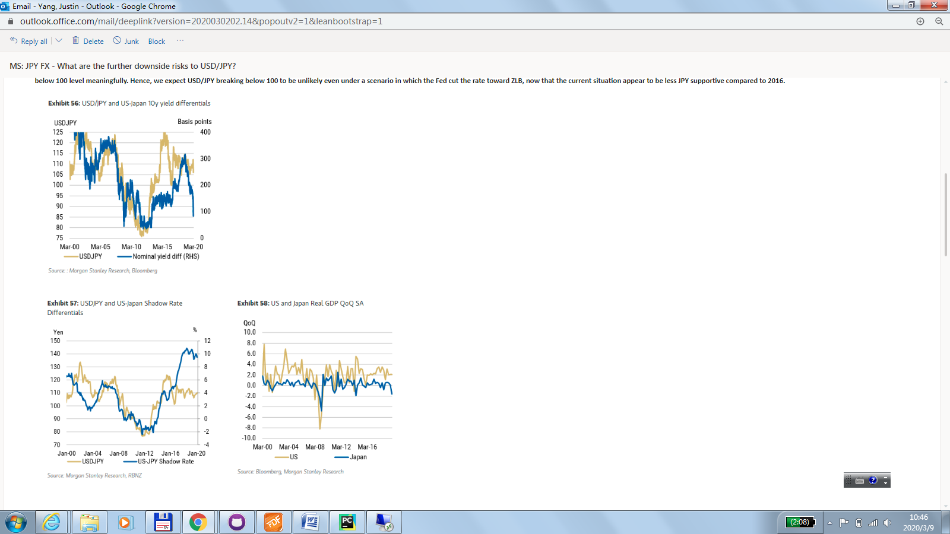

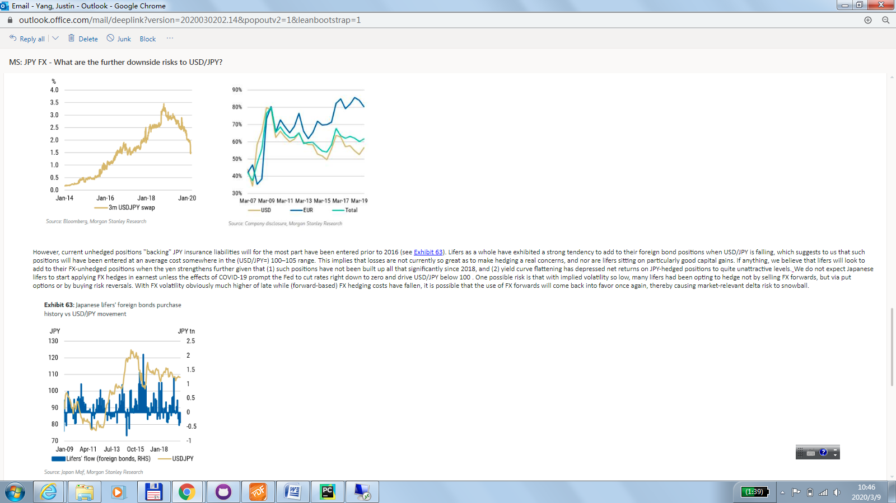

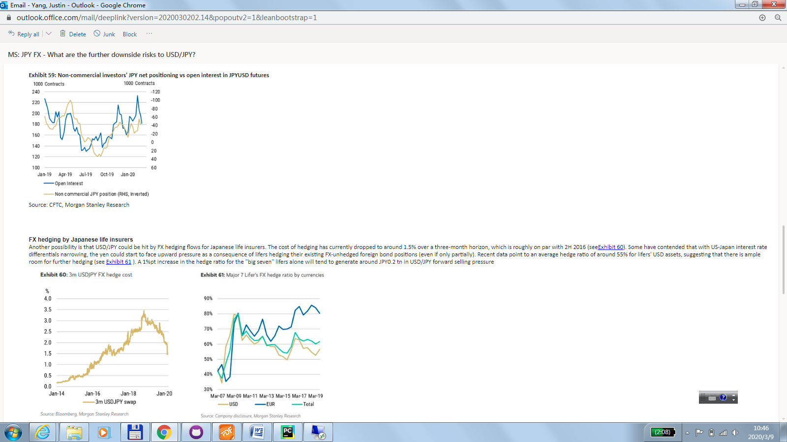

## 20200309 Oil price plunges on Asia countries: HSBC

* more supply shock than a demand shock:
* Singapore, THB, PHP, KRW, TWD would see the biggest savings as measured by their current account balances.
* SGD numbers are flattered by the presence of large petrol-chmical industry. So the net impact is not as big. (ZY: I think it suggest that import petrol are re-export, thus the impact is not that big; secondly there's a downward writing on the companies inventories/hedging book; thus the net impact is less pronounced.
* AUS: has oil trade deficit, however, it has total energy surplus (oil, gas, cola combined). However, a large part of profits in the oil and gas sector are remitted to non-residents.
* MYR: the country run a oil and gas surplus. 10 dollar fall in oil prices roughly reduced fiscal revenue by 0.2% of GDP.
* IDR: Net oil importer but export palm oil and some coal. On balance maybe negative impact
* INR: among the biggest beneficiaries of falling crude oil prices. 10 dollar drop reduces current account deficit by 30-40 bps, raises growth by 10bps, and reduce the inflation by 30bps.
* CAD: oil, mining and gas extraction accounts for 8% of GDP. Oil accounts for 20% of export.

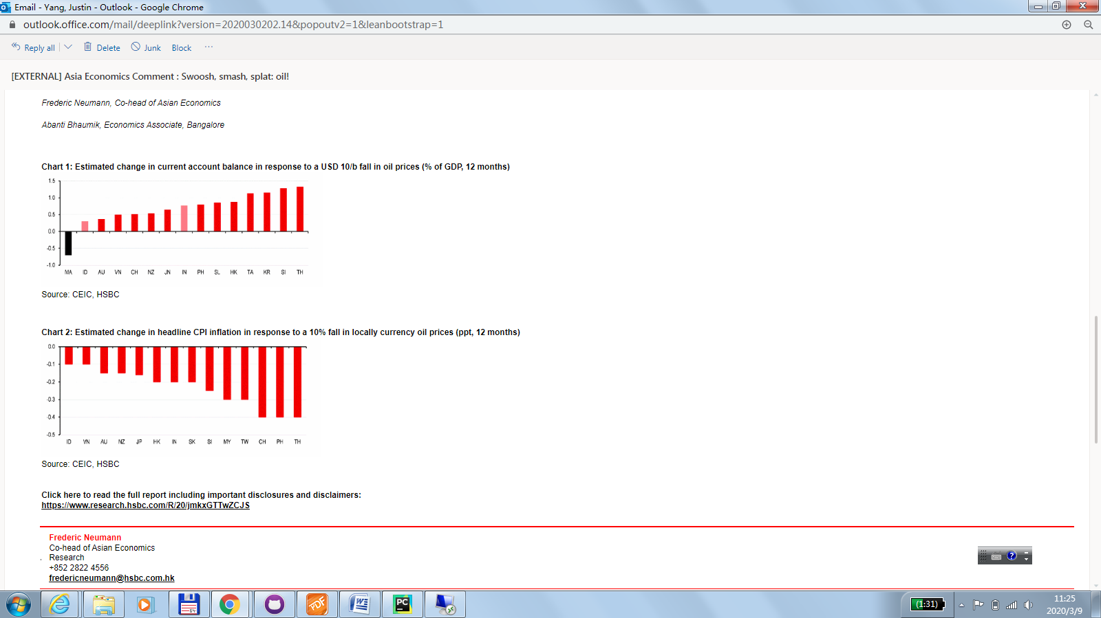

USDJPY: Japan's Government Pension Investment Fund (GPIF) target portfolio:(160 Trillion JPY)

portfolio rebalancing flows